1100 °C Ashing Oven
1100 C Ashing Oven

Potential Hazards while performing these activities
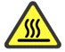 Heat Hazard | This equipment gets extremely hot and can cause burns.
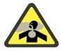 Inhalation Hazard | If liquids are heated, dangerous fumes may be released. This product contains refractory ceramic fiber, which can result in irritation of the skin, eyes, and respiratory tract.
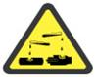 Chemical Hazard | Chemicals may be used with this unit, spills may occur.

Preventions to reduce exposure to hazards:
 Eye Protection | Wear Safety Glasses while operating.
 Protective Gloves | Wear appropriate gloves for heat and chemical use.
 Read Manual/Guide | Become familiar with this guide before operating. Read the manual if you need to use multiple set points.

Note:
This QSG is for single set point operations
Setup Steps | Pictures
- Turn the furnace on by flipping the power switch. Press and HOLD for 3 seconds the “SET/ENT” button to display “modE rES”. | 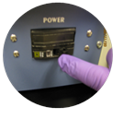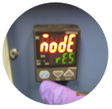
- Press and release the ‘SET/ENT’ button to display “PrG 0”. Press the ‘UP/RESET’ button to show the lower display value of “1”.
- Press and release the ‘SET/ENT’ button to select this new value and advance to the “SSP 25” display.
- Press and release the ‘SET/ENT’ button until the High Temperature Alarm Setpoint value is displayed as “A1”. Select an alarm setpoint 10 degrees C above the target setpoint to be selected. Press and release the ‘SET/ENT’ button to place this new value in the controller memory.
- “Hy1” will be displayed, this completes setup. Press and HOLD for 3 seconds the ‘SET/ENT’ button to exit this menu.
Operation | Pictures
- Press and hold for 3 seconds ‘SET/ENT’ button to display “modE rES”. Press and release the ‘UP’ button twice to select the display “LCL”. | 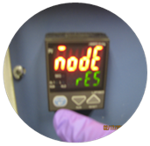
- Press and release the ‘SET/ENT’ button once to select Local Mode. This selection causes the red indicator to illuminate beside “L” on the control panel.  Note: you will hear a “click” when you complete this step. | 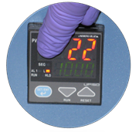
- Use the ‘UP’ and ‘DOWN’ buttons to select the desired operating temperature setpoint. Press and release the ‘SET/ENT’ button once to register the setpoint value.
- Display will show measured temperature in the upper display, the present temperature setpoint in the lower display. | 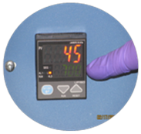
- This display and the buttons will remain active as long as power continues to the control module. Power interruptions will cause the controller to enter reset or standby mode.
- When finished, turn the power off by flipping the power switch and allow the furnace to cool to room temperature before opening. Use hot mitts when removing items from furnace. | 