Branson Sonic Bath - All lab models
Branson Sonic Bath - All lab models
Potential Hazards while performing these activities
Electrical Hazard | This equipment contains electrical components that may come into contact with liquids.
Heat Hazard | This unit produces heat which creates a hazard if improperly operated.
Chemical Hazard | Because chemicals are being placed in this unit, chemical hazards are present.
Vapor Hazard | Because chemicals agents and chemicals are used in the unit, be aware of vapor hazards and use a fume hood if needed.
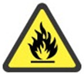 Fire Hazard | Improper use of this unit including the use of incompatible fluids can cause a fire hazard.
Preventions to reduce exposure to hazards:
Eye Protection |  | Safety glasses with side shields must be worn when operating this equipment.
Protective gloves |  | Wear appropriate gloves for heat or chemicals.
Non- slip closed shoes |  | Wear non-slip, closed shoes to avoid hazards from spills.
 Consult LSM |  | Consult the LSM for approved chemicals. Flammable solutions, solutions containing bleach, and mineral acids are not recommended for use in this equipment.
Note: For additional help contact the Laboratory Space Manager (LSM)
Setup Steps | Pictures
- Check to see if the water is already filled to the operating line. If not place water in equipment to the fill line or about 1 inch from the top. Do not operate until water is added to the operating level.  NOTE: Only use next step for new set up and water after cleaning. | 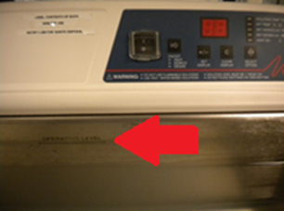
- For degassing the new water turn on power and let run for 5 seconds. Press “Select Option” and select “Set Degas”, use “Set Display” to change timer to 5 or 10 minutes, and press On/Off once. | 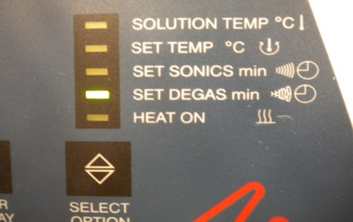
- Once degassing is complete. Place lid on unit and proceed to operation steps. | 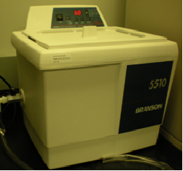
Operation | Pictures
- Choose cleaning solution, including appropriate volume needed. Use a piece of glassware to contain cleaning solution and prevent it from entering the water in the equipment. | 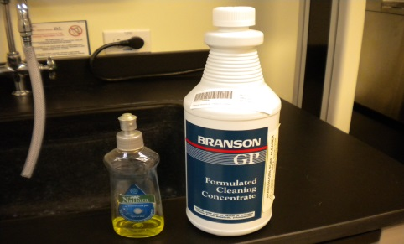
- Press “Select Option” and move status indicator to “Set Sonics”. | 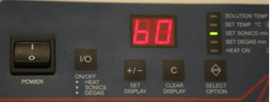
- Use “Set Display” to adjust time for cleaning. Use the “Clear Display “button to clear and reset time. To set temperature, use “Select Option” to move status indicator to “Solution Temperature”. Use the “set display” to adjust. | 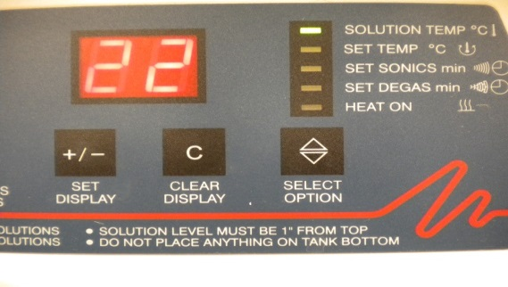
- Slowly lower samples into solution. Do not touch bottom of tank and do not stir solution. Use a basket or beaker to separate samples and bottom of tank. Once all parameters are set and samples are in tank press “On/Off” to begin cleaning cycle. | 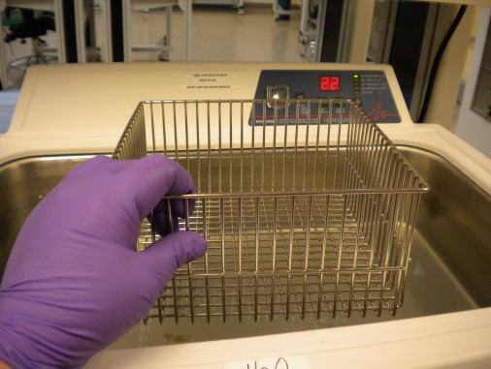
- Once cleaning is finished turn off the main power. Ensure that the solution has cooled. | 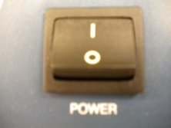
- Do not drain the equipment. The LSM will drain, and clean the equipment if needed. If your samples or cleaning solution have leaked into the water you must notify the LSM for disposal of the water after use. | 