Diamond Saw
Diamond Saw QSG

Potential Hazards while performing these activities
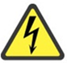 Electrical Hazard | This equipment contains electrical units that may come into contact with skin or liquids.
 Chemical Hazard | This equipment is used near potentially hazardous chemicals.
Dust Inhalation Hazard | Dust may be created during cutting.
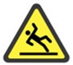 Slip Hazard | Liquids from the unit may fall on the floor, causing slippery conditions.
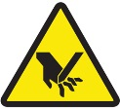 Cut Hazard | Be careful of the blade when working with the saw.
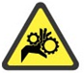 Pinch Hazard | When opening and shutting the door to the lubrication water trough, be careful not the pinch a finger.

Preventions to reduce exposure to hazards:
  Eye Protection | Wear safety glasses while operating.
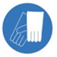  Protective Gloves | Wear appropriate gloves for chemical usage.
  Non-Slip, Closed Shoes | Wear non-slip, closed shoes to avoid spills.
  Read Manual | Become familiar with this guide before operating.

Note:
Safety glasses must be worn at all times when operating the saw. If you spill the coolant fluid, please follow the directions provided on the spill kit to clean up the material and contact the LSM to notify them of the spill.
Preparation Before Operation Steps | Pictures
- Ensure work area is stable; saw should not shake during operation.
- Check all parts and ensure they are clean; if they are not, it could affect the precision of the saw.
- Obtain pre-mixed coolant (1 oz powder to 1 gallon of water). | 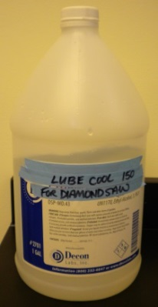
- Plug in the saw and turn it on. | 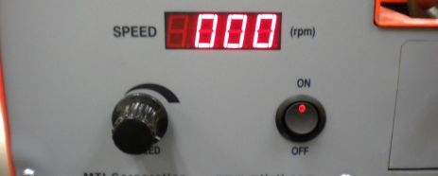
- Make sure the working arm is pushed all the way up and away from the blade. Turn the speed up past 50 rpm and let the machine run for 30 seconds. Check for abnormalities. Do the next step before the 30 seconds are up. | 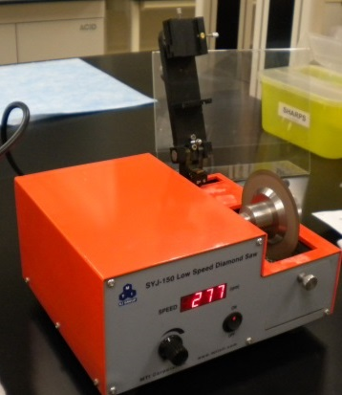
- Check that the position-limit switch is in good working condition to protect the blade. Do this by pushing on it while the arm is up and the blade is running and ensure it stops the blade. | 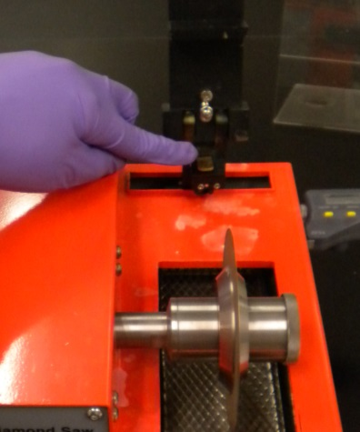
- Perform the following in order: turn the speed back to zero, turn the saw off, and unplug the saw.
Note:
Steps 1 and 2 could already be completed. Look for an aluminum and graphite plate already mounted together.

Preparing/Mounting a Sample | Pictures
- Place an aluminum mounting plate onto a hot plate. Heat plate to 120C. | 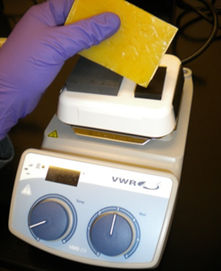
- Place the graphite plate onto the aluminum mounting block using low melting point wax.
- Melt another piece of wax on top of the graphite plate where the sample is to be mounted. | 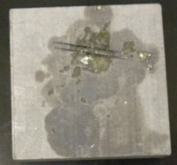
- Place the sample onto the graphite plate and remove the entire assembly from the hot plate. Let it cool for about 2 to 3 minutes.
- Place the aluminum block with the mounted sample onto the goniometer sample holder by loosening the thumbscrew on the side of the goniometer. Tighten the thumbscrew when the assembly is in place. | 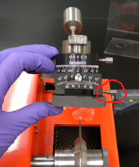
Preparation Before Cutting | Pictures
- Choose a suitable position for the working arm by making sure that the blade reaches the graphite block and then is turned off with the position limit switch. If the position-limit screw is too long, it may cause the machine to stop running before you finish the cut. Determine the correct length of the screw by measuring the correct distance to the graphite plate next to where the sample is mounted, on a clean graphite surface. The weight should be adjusted so the correct amount of pressure is applied. This step is necessary to ensure the micrometer (9) will function properly. | 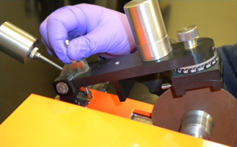  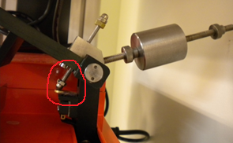
- Tighten the gold position limit screw ring to preserve the correct length of the screw. | 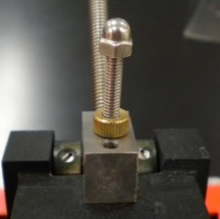
- Tighten the screws on the sample holder for two angle adjustment and sample holding plate. | 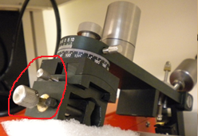
- Adjust the sample position to line up with the blade using the micrometer. Make sure the micrometer is on. | 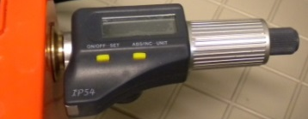
- Place coolant into lubricating water trough until the lubricant covers approximately ½” of the diamond wheel. | 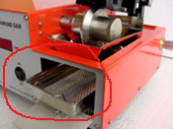
Operation Steps | Pictures
- Plug in the saw and turn on the main power by pressing the ON/OFF power switch. | 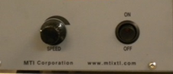
- Make sure the sample is away from the blade and adjust the speed using the control knob on the front of the saw. Higher speed is better for materials with low hardness.
- Gently lower the arm with the sample onto the diamond wheel to begin cutting. | 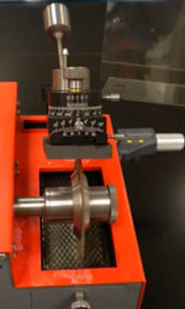
- When cutting is complete, raise the arm into the up position and turn the main power switch to the OFF position. | 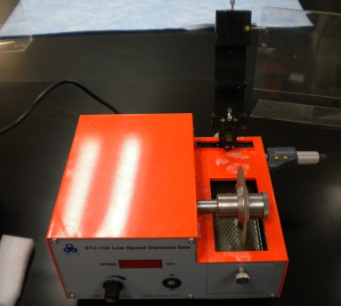
- Remove the entire assembly from the saw. Place it back onto the hot plate to melt the wax. Remove the sample and clean it thoroughly. | 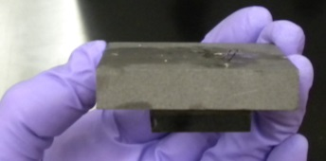
- Leave the saw in the condition you found it in. The saw should be clean and ready for the next user. Notify the LSM when you are finished and they will dispose of the used coolant from the saw.

PLEASE NOTE:
An LSM approved chemical work sheet that includes all hazards associated with the material being cut MUST be posted in the work area.

