Dry Bath/Heat Block
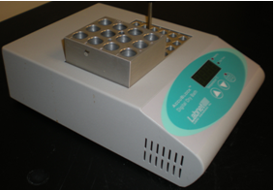
Potential Hazards while performing these activities
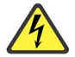Electrical Hazard | This equipment contains electrical units that may come into contact with skin or liquids.
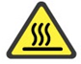 Heat Hazard | This equipment produces heat and may cause burns.
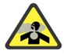 Vapor Hazard | Chemicals that are heated could produce a vapor hazard.

Preventions to reduce exposure to hazards:
Eye Protection | Wear safety glasses with side shields while operating. If vapors will be produced, use equipment inside a fume hood.
Protective Gloves | Wear appropriate gloves for heat and chemical usage.
Non-slip, closed shoes | Wear non-slip, closed toed shoes to avoid slipping.
Read Manual | Become familiar with this guide before operating.

Note:
If you have additional questions about the operation of this equipment contact the LSM.

Setup and Operation steps | Pictures
- Verify that unit is plugged in. Turn on main power switch. Press and release either the UP or DOWN ARROW button once and the display will flash the existing set point temperature established. | 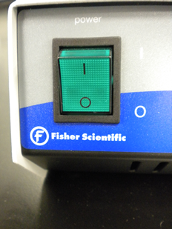
- To Change temperature set point, press the appropriate UP or DOWN button to raise or lower temperature. Once desired temperature is reached release button. When the display stops flashing the new set point is established. Maximum temp is 130 c. | 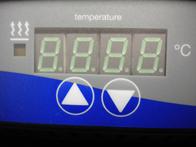
- Place samples in appropriate metal block to fit the size of your sample container. Heat for needed duration. | 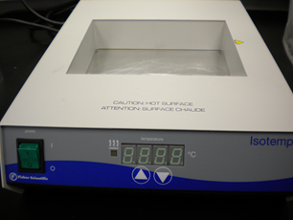
- When heating is finished turn off the power. Use the screw handle and protective heat glove to remove block with samples. It is recommended to allow samples to cool before handling. | 