Labconco Freeze Dryer
Labconco Freeze Dryer

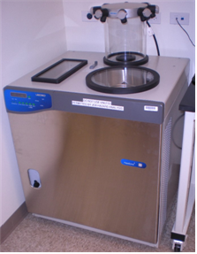
Potential Hazards while performing these activities
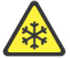COLD HAZARD | This equipment contains freezer units which may cause cold related injuries.
SLIP HAZARD | Liquids from this unit may fall on the floor, causing slippery conditions.
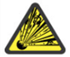 VACUUM HAZARD | This unit operates at negative pressure and can create a vacuum hazard if improperly used.
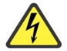ELECTRICAL HAZARD | This equipment contains liquid near electrical connections.

Preventions to reduce exposure to hazards:
Eye Protection | Wear safety glasses with side shields while operating.
Protective Gloves | Wear appropriate gloves for chemical usage.
Non-slip, closed shoes | Wear non-slip, closed toed shoes to avoid slipping.
Read Guide | Become familiar with this guide before operating.  The operating manual is also available for reference.

Note:
For specialty applications of manual mode consult the instrument user manual. If you have additional questions about the operation of this equipment contact the LSM.

Setup Steps | Pictures
- Place samples in -80 C freezer for the desired amount of time. The sample container should be 2 to 3 times larger than the samples. Seal top of vessel with perforated parafilm to allow solvent to be removed from sample during freeze-drying. Meanwhile get the freeze dryer ready for operation. | 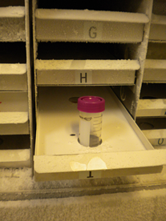
- Check that the collector chamber is clean and dry. Replace lid | 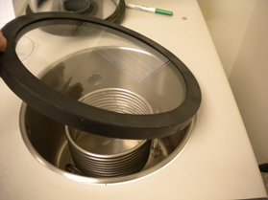
- Make sure that the sample valves are positioned to the vent position (Bevel points upwards)

- Power up the freeze dryer, the power switch is on the left-hand side of the cabinet. The alarm will beep a few times and stop. If it continues call the LSM.

- To run in auto mode, press the panel button labeled REFRIDGERATION AUTO. This will initiate refrigeration and once -40oC is reached the vacuum will start. When the system vacuum level is at ~ 0.14 mBar, samples can be added. | 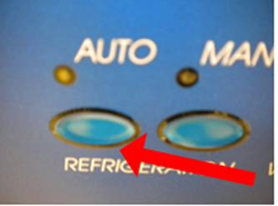
Operation | Pictures
- Glass vacuum containers, adapters and filter paper are available in the lab glassware cabinet. Be sure to place a filter paper in the top of the sample container lid first. Then connect the pre-frozen sample to a sample valve on the manifold. Turn the plastic knob to the vacuum position. The bevel points towards the sample port (facing down) | 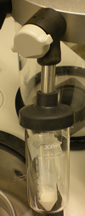
- Before adding a second sample, allow the vacuum level to return to ~ 0.14 mBar | 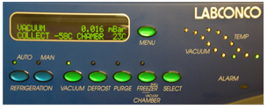
- To remove a sample, turn the plastic knob on the sample valve to the vent position (Bevel points up). This will close the valve and vent the sample container | 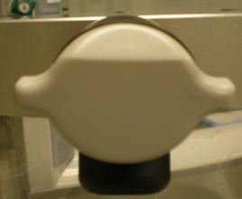
Shut-down Procedure | Pictures
- Release system vacuum by turning the plastic knob to the vacuum position (this is the open position with bevel facing down) | 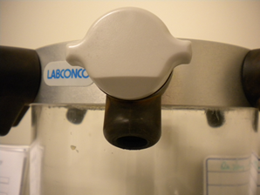
- Press the vacuum button on the control panel to turn the vacuum off then press the refrigeration button next to the illuminated LED to turn off the refrigeration system. | 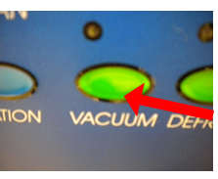
- Turn off the Main power switch on the left-hand side of the cabinet. | 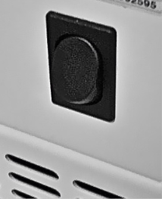
- Place a suitable collection container below the drain spout. Open the valve on the drain and allow excess water to drain. | 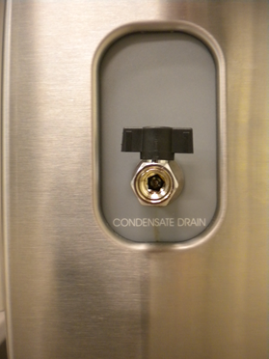
- Add a small amount of warm water to melt ice around coils. Once it has melted enough, the ice can be manually removed. [Important Note: The water should not cover more than the bottom 2 coils otherwise water may drain into vacuum pump]  Flush collector chamber with water (see note above) and wipe dry. | 