Gravity Oven
Gravity Oven

Potential Hazards while performing these activities:
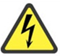 Electrical Hazard | This equipment contains electrical units that may come in contact with skin or liquids.
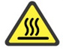 Heat Hazard | This unit produces heat which creates a hazard if improperly operated.
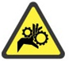 Pinch Hazard | This equipment has a door which may pinch body parts or clothing.
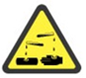 Chemical Hazard | Because chemicals are being placed in this unit, chemical hazards are present.
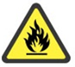 Fire Hazard | Any improper use of this equipment may cause a fire hazard.

Preventions to reduce exposure to hazards:
  Eye Protection | Wear safety glasses while operating.
  Protective Gloves | Wear appropriate gloves for heat and chemical usage.
  Non-Slip, Closed Shoes | Wear non-slip, closed shoes to avoid spills.
  Read Manual | Become familiar with this guide before operating.

Note:
DO NOT place sealed or full samples within unit. DO NOT place explosive, combustible, or flammable materials inside.

Setup Steps | Pictures
- Ensure oven is plugged in and on a stable surface. | 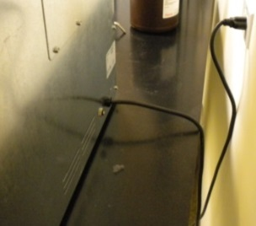
- Turn the main power switch on. | 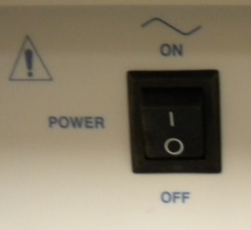
- Turn Overtemperature Control CLOCKWISE to maximum setting. | 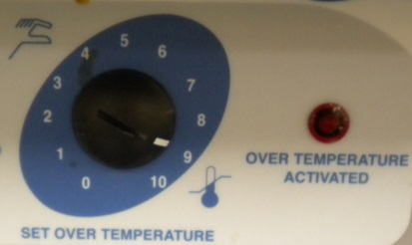
- Turn the Main Temperature Dial to desired temp. ALLOW ONE HOUR for temperature to stabilize. | 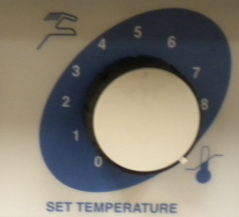
- Once Main Temperature has STABILIZED, turn the Overtemperature Control Counterclockwise until the safety light comes on. | 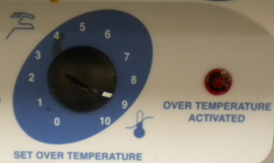
- Next, turn the Overtemperature Control CLOCKWISE until light goes out, and then 2 DIVISIONS MORE.
- Unit is now ready to receive samples.
Operation | Pictures
- Place samples inside of unit. UNIT WILL BE HOT! Please wear appropriate PPE. | 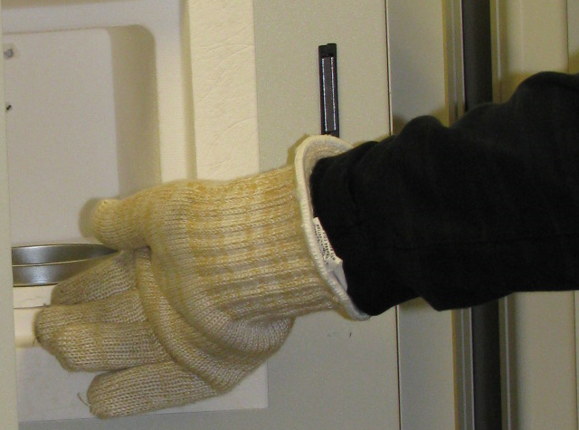
- Ensure door is shut and latch closed. | 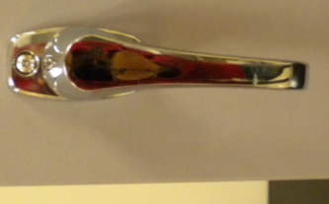
- Upon completion. Turn unit power off, and return dials to original settings.
- After UNIT HAS COOLED, remove samples.

