Jasco FTIR
Jasco FTIR

Potential Hazards while performing these activities:
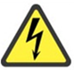 Electrical Hazard | This equipment contains electrical units that may come in contact with skin or liquids.
 Slip Hazard | Because chemicals are moved near this unit, a slip hazard may be created.
 Pinch Hazard | The glass door to the unit may shut and cause a pinch hazard.
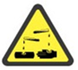 Chemical Hazard | Because chemicals are being used in/near this unit, chemical spills are possible.
 Fire Hazard | Improper use of this equipment may cause a fire hazard.

Preventions to reduce exposure to hazards:
 Eye Protection | Wear safety glasses while operating.
 Protective Glove | Wear appropriate gloves for heat and chemical usage.
 Non-Slip, Closed Shoes | Wear non-slip, closed shoes to avoid spills.
 Read Manual | Become familiar with this guide before operating.

Note:
The Resume switch needs to be left ON at all times as well as the Power switch used to initialize the spectrometer for spectra collection.

Setup Steps | Pictures
- Make sure the Resume switch is ON. If Resume has been turned off, turn it on and wait 5-10 mins. | 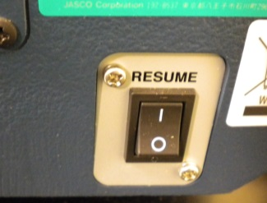
- Turn the Power switch ON to initialize the spectrometer and wait for 3 beeps to sound. | 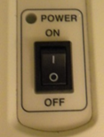
- Turn computer on and double click the Spectra Manager Icon | 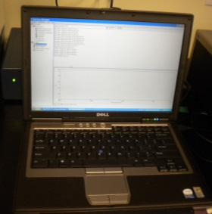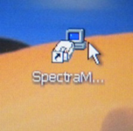
- Double Click Spectra Measurement | 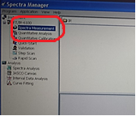
- Set measurement parameters on computer (User’s manual pg. 21). Scan Range, Accumulation, and Resolution are the only areas that should need changed. | 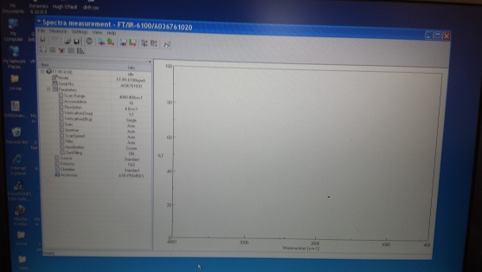
- Make sure iQ Accessory says ATR PRO 450-S. | 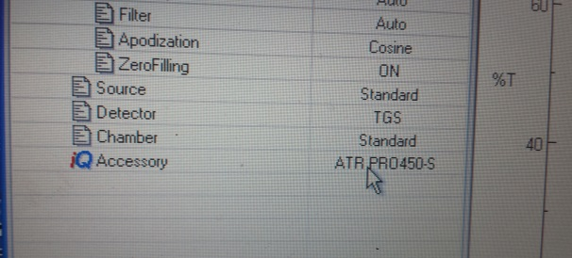
- Set up a Background measurement. Ensure sample chamber is empty and the ATR crystal is clean. To clean the crystal use water and kim wipe with NO PRESSURE. The crystal is very fragile. | 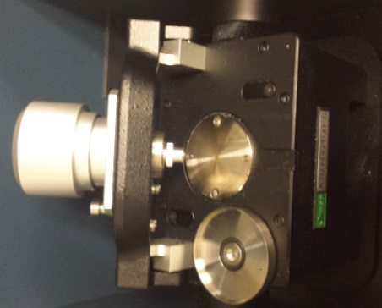
- Click the B (background) button to record the background measurement. Wait for the progress bar to finish. | 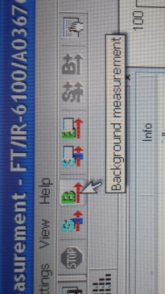
Operation | Pictures
- Open sample chamber lid. | 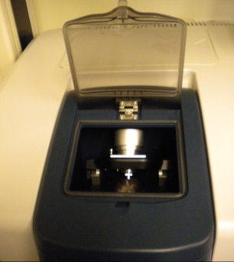
- Place sample on ATR crystal. | 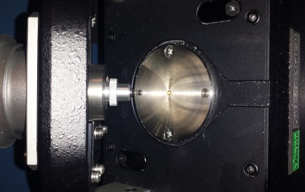
- For liquid samples put directly on crystal and put evaporation cap on. For solid samples, place on crystal and rotate the screw cap forward. To do this, you have to release the pin in the back. Screw the cap down onto the sample until you can no longer tighten down. | 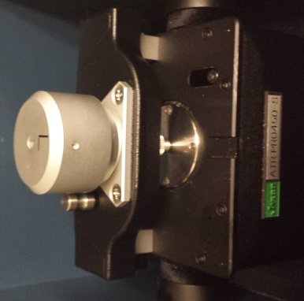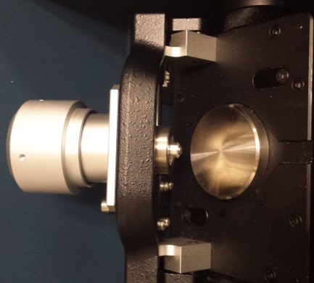  For liquid samples with evaporation cap on.  Tilt Pin  For solid samples with the screw cap tightened all the way down.
- Bring the Screw cap back up before tilting it back.
- Press the sample measurement button to record data. | 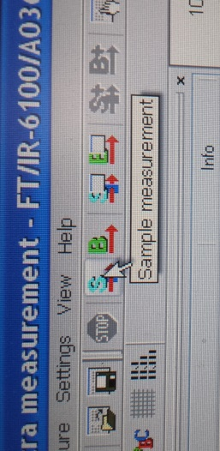
- To Save, select [Save As…] on the screen and follow prompts.
- Make sure that the stage is clean.
- Exit program when done and turn off Power to unit. Make sure the software is exited before the unit is turned off. | 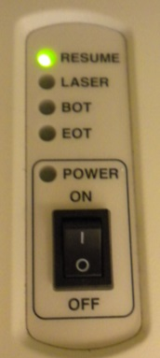
- LEAVE RESUME SWITCH ON. | 