Multiple Position Magnetic Stirrer
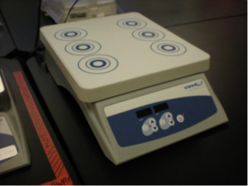
Potential Hazards while performing these activities
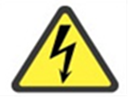 Electrical Hazard | This equipment contains electrical components that may come into contact with liquids.
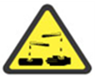 Chemical Hazard | Because chemicals are being placed on this unit, chemical hazards are present.
Slip Hazard | Liquids from agitating vessels may spill on floor and cause a slipping hazard.

Preventions to reduce exposure to hazards:
Eye Protection | Wear safety glasses with side shields while operating.
Protective Gloves | Wear appropriate gloves for chemical usage.
Non-slip, closed shoes | Wear non-slip, closed toed shoes to avoid slipping.
Read Manual | Become familiar with this guide before operating.

Note:
If you have additional questions about the operation of this equipment contact the LSM.

Setup Steps | Pictures
- Ensure that the unit is plugged in. Ensure that all samples are in sealed containers or splash proof flasks.
Operation | Pictures
- Turn unit POWER on or push power button, depending on the model. Place samples in stir area centered on circles. | 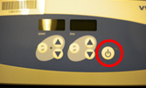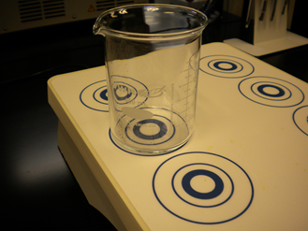
- Set desired speed of agitation using arrow keys. If a timed agitation is desired, adjust the time with the arrow buttons. Adjustment of speed and time should be done before pressing the “ON” button to the left of each setting. Push “OFF” to stop timer if needed. | 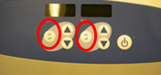
- Turn off agitation when finished and clean equipment after use. | 