Sartorius CPA6202 Balance
Sartorius CPA6202 Balance

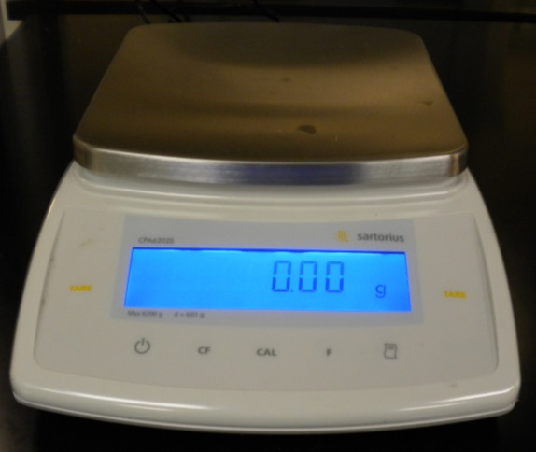
Potential Hazards while performing these activities:
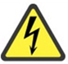 Electrical Hazard | This equipment contains electrical units that may come in contact with skin or liquids.
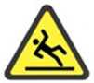 Slip Hazard | Because chemicals are being moved near this unit, a slip hazard may be created.
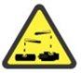 Chemical Hazard | Because chemicals are being moved to the balance surface, chemical spills are possible.
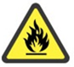 Fire Hazard | Any improper use of this equipment may cause a fire hazard.

Preventions to reduce exposure to hazards:
Eye Protection | Wear safety glasses while operating.
Protective Glove | Wear appropriate gloves for heat and chemical usage.
Non-Slip, Closed Shoes | Wear non-slip, closed shoes to avoid spills.
Read Guide | Become familiar with this guide before operating.

Setup Steps | Pictures
- Ensure unit is plugged in.
- If the bubble is not centered, adjust the level of the scale by rotating the front feet until the bubble is centered in the indicator. | 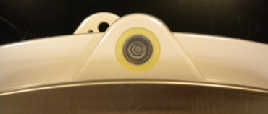
- Ensure the weighing surface is clean of debris and ready for use. | 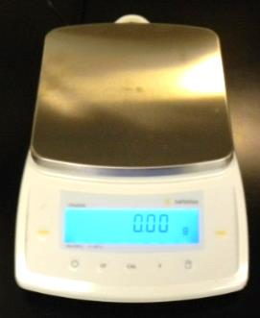
- Turn the power on and wait until the self-test sequence completes.
- Press the Tare button to zero the balance.
Operation | Pictures
- Once setup is complete, materials can be weighed on the balance.
- To erase a weight, press cancel. (e.g. in between samples) Tare can be used to zero the weight for items such as weigh papers.
- When finished, press the power button to turn off.
- Please ensure work area is free of chemicals and supplies after use.

