Hot Plate/Stirrer
Hot Plate/Stirrer

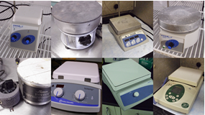
Potential Hazards while performing these activities
Electrical Hazard | This equipment contains electrical units that may come into contact with skin or liquids.
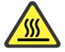 Heat Hazard | This equipment produces heat and may cause burns.
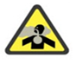 Vapor Hazard | Chemicals that are heated could produce a vapor hazard.
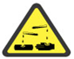 Chemical Hazard | Chemicals may be stirred at a high rate of speed. Splashes and spills are possible.
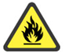 Fire Hazard | Any improper use of this unit may cause a fire hazard.

Preventions to reduce exposure to hazards:
 Eye Protection | Wear safety glasses with side shields while operating.
 Protective Gloves | Wear appropriate gloves for heat and chemical usage.
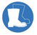 Non-slip, closed shoes | Wear non-slip, closed toed shoes to avoid slipping.
 Read Manual | Become familiar with this guide before operating.

Note:
If you have additional questions about the operation of this equipment contact the LSM.

Setup | Pictures
- Ensure the unit is plugged into an outlet. Check for any debris or combustible materials around the area of the hotplate. | 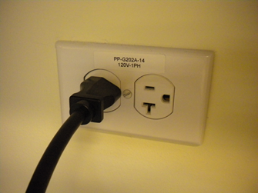
- Use containers appropriate for heating/splashing and clamp if needed. When heating a closed vial with potential vapor build up use pressure rated glass vials provided. Contact LSM for advice on the appropriate container if needed. | 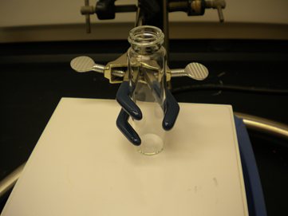
Operation | Pictures
- Turn unit POWER on and adjust heat to desired temperature. When temperature is achieved the temp light will illuminate. | 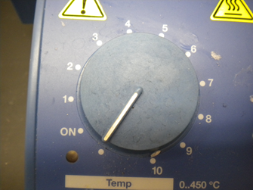
- Place sample in the center of the plate. | 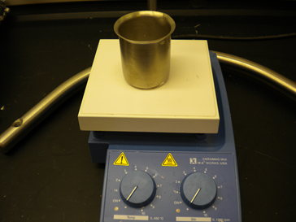
- If stirring is needed adjust the speed of agitation. Once the speed is achieved the light will illuminate. | 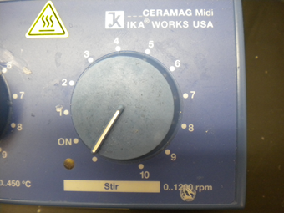
- When heating and stirring duration is complete turn POWER off before removing sample. Allow to cool or use a protective heat glove to remove sample container. | 