**Vortex Mixers – General for all models**

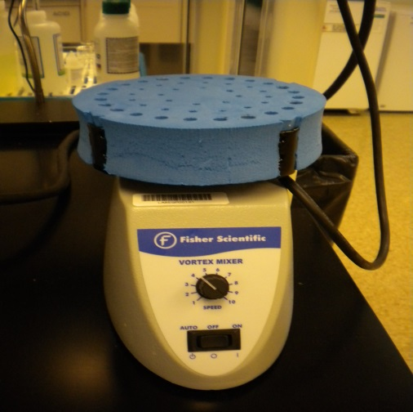

|  |  |
| --- | --- |
| Potential Hazards while performing these activities | |
| Electrical Hazard | This equipment contains liquid near electrical connections. |
| Slip Hazard | Liquids from agitating vessels may spill on floor and cause a slipping hazard. |
| Chemical Hazard | Improperly sealed vessels may cause splashing and present a chemical exposure hazard. |
| Sharps Hazard- | When glass containers are used with this equipment, a sharps hazard could occur if glass is broken. |

|  |  |
| --- | --- |
| Preventions to reduce exposure to hazards: | |
| Eye Protection | Wear Safety Glasses while operating. |
| Protective Gloves | Wear appropriate glove for chemical use. |
| Read Manual / Guide | Become familiar with this guide before operating. |

|  |
| --- |
| Note: If you have questions about the operation of this equipment after reading this guide ask the LSM. |

|  |  |
| --- | --- |
| Setup Steps | Pictures |
| Verify the power switch is in the off position. Ensure unit is plugged in. Make sure the agitation knob is turned all the way down or off. There are 2 modes that can be used with this equipment: continuous and on-demand. See operation section for guidance to use both modes. |  |
| Operation (Continuous) | Pictures |
| 1. Turn the power switch to “on” for continuous operation. Place the sealed vessel to be agitated into the foam holder. |  |
| 1. Adjust the speed setting until the desired agitation is reached. |  |
| 1. Switch the power off when you are finished with the mixer. |  |
| Operation (On demand) | Pictures |
| 1. To use the on-demand option the equipment power button must be set to “auto” and one of the rubber head attachments should be used.   NOTE: To remove attachments pull straight up. |  |
| 1. Place your sealed vessel on the rubber head of the mixer and apply pressure until the agitation begins. You must hold the vessel in place during the mixing period. Adjust speed of agitation if needed. The mixer will stop when you remove the pressure and vessel from the head. |  |
| 1. Turn off power when finished. |  |

Vortex mixers- General for all Models.