BASIS User Manual

Eugene Mamontov, Niina Jalarvo, Naresh Osti, Christopher J. Schmitt

Neutron Scattering Division
Neutron Sciences Directorate
Oak Ridge National Laboratory

September 5, 2020

Table of Contents Page
1. Introduction 3
2. Description of the SNS Backscattering Spectrometer, BASIS 4
3. The Indirect Geometry Method - General 7
4. Specifics of the Indirect Geometry Method on BASIS 9
5. Data Collection 13
6. Data Reduction 23
7. Data Output Formats 27
8. Appendix 27

Section 1. Introduction

The purpose of this User Guide is to provide guidelines for collection and reduction of neutron scattering data from the SNS backscattering spectrometer, BASIS. The information included in this Guide should be sufficient for the BASIS users to reduce the data independently. Because the data reduction process may be reviewed and improved periodically, there may be updates that have not been included in the present version of the Guide; such instances will be indicated in the text, and you should consult the instrument personnel.

Section 2. Description of the SNS Backscattering Spectrometer, BASIS

The BASIS is an acronym that stands for Backscattering Silicon Spectrometer. BASIS is an indirect geometry spectrometer located on BeamLine 2 (BL2) at the Spallation Neutron Source (SNS). It has a sample position located in an external building (see Figure 1) some 84 m from the top upstream decoupled (and poisoned) liquid H₂ moderator. The beam is transported to the sample position (inside the instrument tank; see Figures 1 and 2) through a system of guides located along the corridor connecting the BASIS external building with the main target building.

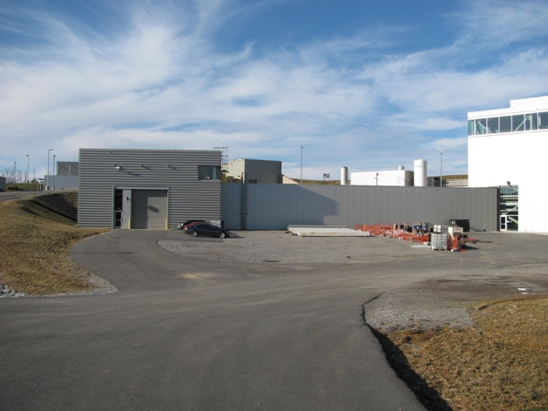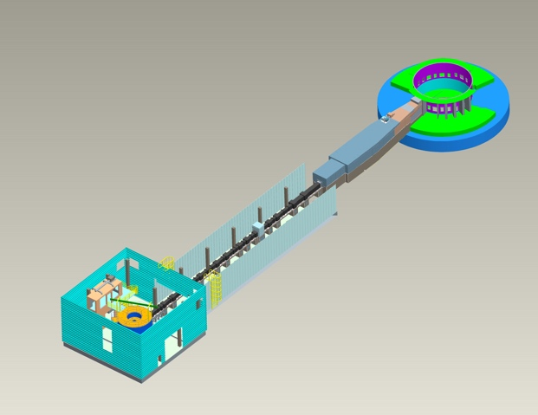
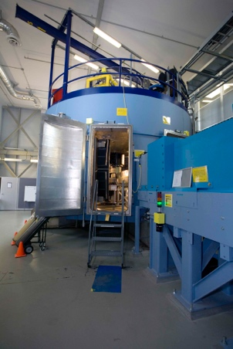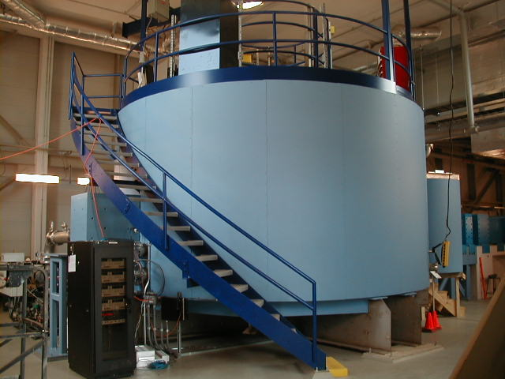
Figure 1. Top, left: BASIS external building. Top, right: BASIS overall schematics. Bottom, left: BASIS tank view (with the door open) from the corridor connecting the BASIS external building to the main target building. Top, right: BASIS tank view from the floor of the BASIS external building.
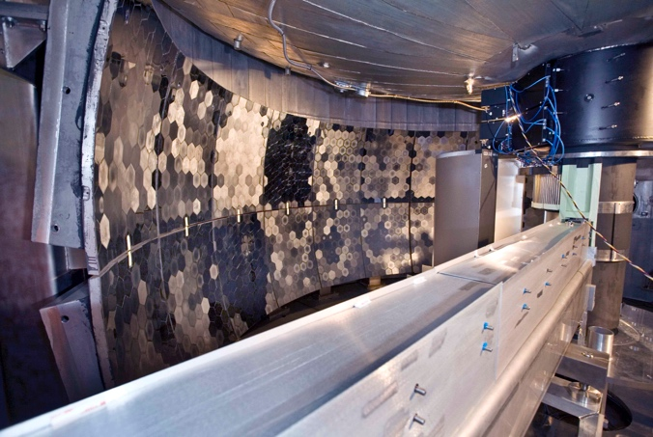
Figure 2. Inside the BASIS tank, view from the open tank door. Shown are the incident beam guide (enclosed in the shielding) and the crystal analyzer panels.

BASIS is used for high-energy resolution (typically 3.0 to 3.5 μeV, FWHM, at the elastic line) measurements with a relatively wide, variable energy transfer range, and the momentum transfer of 0.2 Å⁻¹ < Q < 2.0 Å⁻¹, with Q-resolution that varies between 0.05 and 0.10 Å⁻¹. BASIS experiments usually measure quasielastic scattering (due to diffusion or relaxational motions on the pico- to nano-second time scale), or low-energy inelastic scattering. An example of an experiment that probes both quasielastic and inelastic scattering is shown in Figure 3.

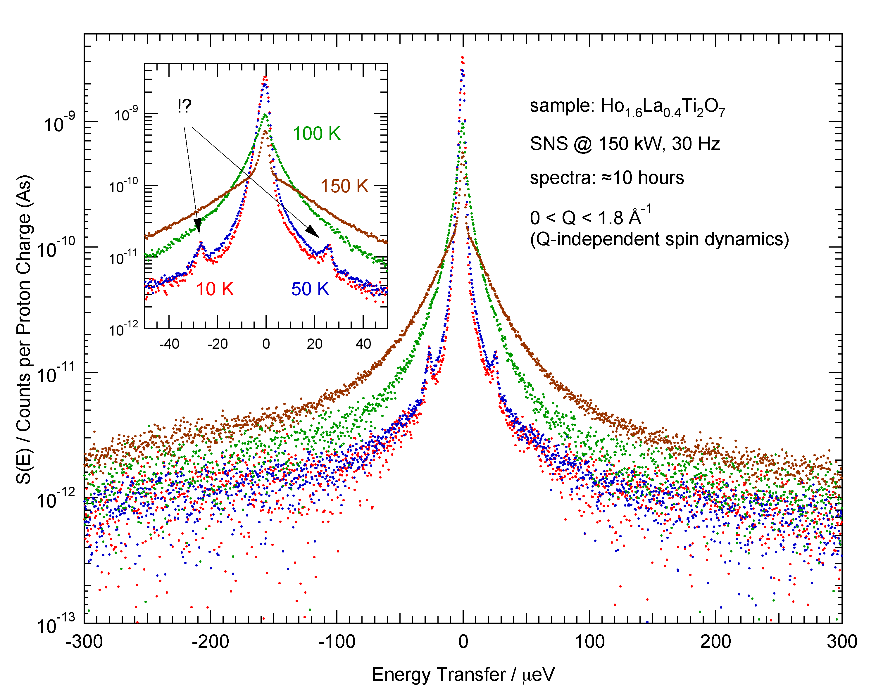
Figure 3. Quasielastic scattering and inelastic excitations measured simultaneously on BASIS.

The important parameters of the Beamline 2 are as follows.

Moderator-to-sample distance: 84.000 m. On the way to the sample, neutrons pass though the incident bandwidth-defining choppers (at 7.000, 9.250, and 50.000 m) and the incident beam monitor (at 83.766 m, or 0.234 m upstream the sample position).
Sample-to-analyzers distance: 2.500 m (for a point sample)

Analyzers-to-detectors distance: variable, from 2.710 m to 2.729 m. Each detector pixel row has its unique analyzer-to-detector distance, defined by the Bragg reflection geometry of the analyzers, as we will discuss below. The data reduction routine takes this spread into account. Assuming a single analyzer-to-detector distance (thus, neglecting the actual spread) leads to the energy resolution degraded by about 50 %. Furthermore, the Bragg-reflected wavelength is also a function of the pixel row: it varies slightly between 6.2671 Å to 6.2678 Å. The detailed explanation of the pixilation of the BASIS linear position-sensitive detectors will be given in the next Sections.
Section 3. The Indirect Geometry Method - General
In general, on a TOF spectrometer, the scattering intensity is measured as a function of energy transfer, E = E_{i} – E_{f}, where E_{i} and E_{f} is the incident and final (detected) neutron energy, respectively. In the indirect (or inverted) TOF geometry, the E_{f} is fixed (for example, defined by a filter or an analyzer crystal), whereas the E_{i} is variable, and can be determined from the neutron TOF. In the extreme case of a backscattering TOF spectrometer, the E_{f} is known very precisely by means of utilizing back reflection from analyzer crystals. Thus, the energy transfer, E, can also be measured very precisely, if one knows the E_{i} with equally good precision. Usually, the precision of measuring E (the energy resolution) of the inverted geometry backscattering spectrometer is higher compared to that of a direct geometry spectrometer. For example, a typical BASIS spectrum collected from an incoherently scattering vanadium standard is shown in Figure 4.

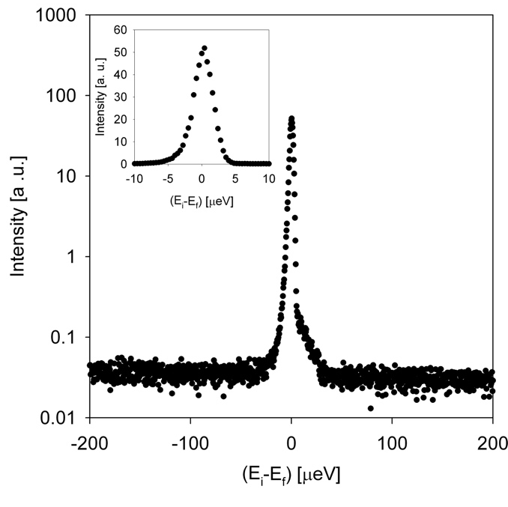
Figure 4. Q-averaged spectrum collected from a 10 % scattering annular vanadium standard showing the energy resolution of the BASIS of about 3.5 μeV, FWHM.
Another important feature of the inverted geometry spectrometer is the access to a generally wider (compared to direct geometry spectrometers) range of neutron energy loss side (see Figure 5 for the range accessible on the BASIS).
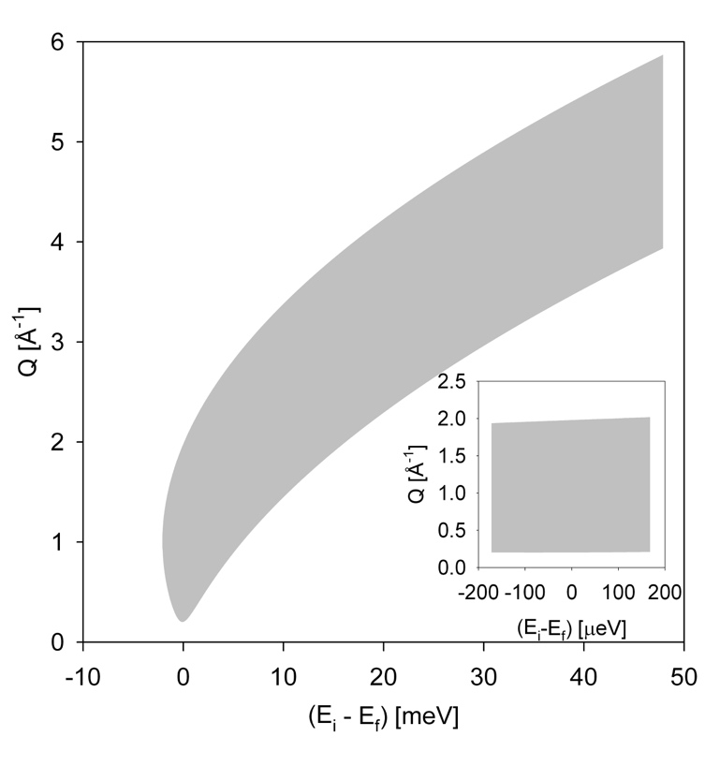

Figure 5. Q-E region accessible on the BASIS (note: it will require several measurements with different choppers settings to cover the entire range shown). Inset: typical Q-E coverage in the quasielastic measurement regime at 60 Hz.

A disadvantage of the indirect geometry spectrometers is a generally higher level of the lowest attainable background, which is a direct consequence of admitting a relatively wide incident wavelength band inside the spectrometer, as opposed to just a single wavelength at a direct geometry spectrometer.
Section 4. Specifics of the Indirect Geometry Method on BASIS
How do we measure scattering on the BASIS? Schematically, BASIS works as follows. For each accelerator pulse, the system of choppers transmits a wavelength band of neutrons of about 0.5 Å wide (when the choppers are operated at 60 Hz) that travel from the moderator to the sample through the neutron guide. Alternatively, the choppers can be operated at a sub-harmonic frequency (e.g., 30 Hz); in such a mode, the incident wavelength band is extended, albeit at the expense of missing some accelerator pulses.

The list of “corrections” that need to be applied to reduce BASIS data are as follows

- For the variation of the moderator emission time T0(E_{i}) as a function of E_{i}
- For the variation of the incident flux Φ(E_{i}) as a function of E_{i}
- The variation of the final (analyzing) energy and flight path distance for different detector pixels because of the spherical symmetry of the analyzer crystals
- The variation of the solid angle subtended by different detector pixels (via the analyzer crystals) at the sample position
- The variation of the detector efficiency does not need to be taken into account (unlike for the incident beam monitor) because single wavelength gets registered at the detectors
- The variation of the analyzer crystal reflectivity across the analyzer panels and from analyzer panel to analyzer panel
- The masking out of noisy or inaccessible (via Bragg scattering from the analyzer crystals) detector pixels

Moderator Emission Time Variation T(Ei)
It takes some time after the prompt pulse for the moderated neutron pulse to get emitted from the moderator; the faster neutrons have shorter emission times. In the BASIS data reductions, the emission times are assumed to be linearly dependent on the incident wavelength: . The slope and offset parameters are updated depending on the state of the moderator.

Variation of the Incident Flux Distribution Φ(E_{i})
The incident band is non-uniform in intensity as a function of wavelength. At each value of the incident wavelength, the intensity is a product of the moderator output, transmission through the guide, and absorption in the thin aluminum windows that separate multiple sections of the guide. To measure the wavelength distribution of the incident spectrum, the incident beam monitor (IBM) is positioned upstream the sample position. As a result, the TOF spectrum at the IBM is shifted toward shorter TOFs, and also has a slightly shorter TOF span compared to the detector spectrum (Figure 6).
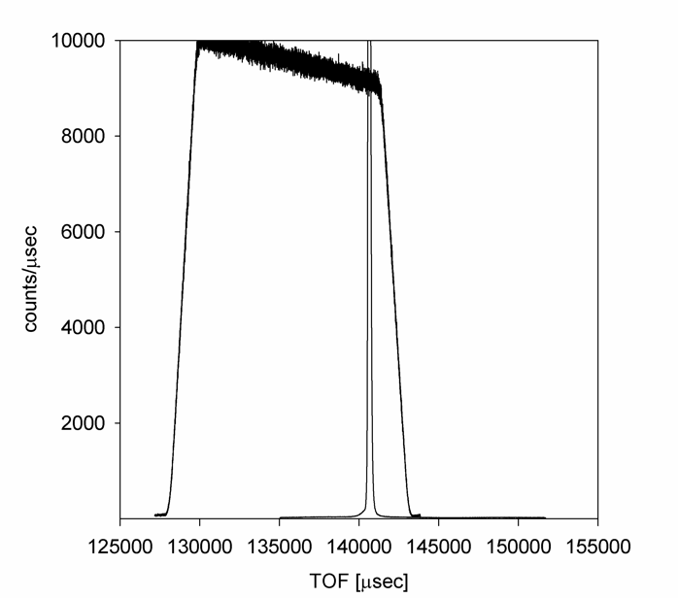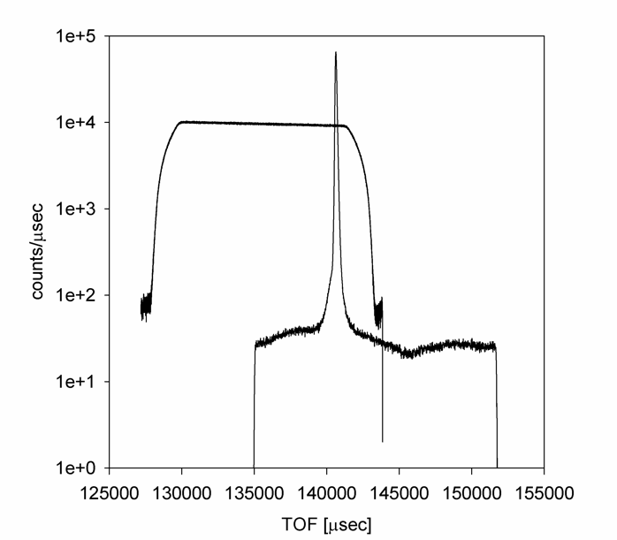
Figure 6. TOF signal from a sample measured at the detectors (with the elastic peak at about 140,600 μsec) and the incident beam monitor. Left: linear scale. Right: logarithmic scale.

Therefore, the counts need to be expressed in the unit of incident wavelength rather than TOF before normalization to the IBM can be performed.

Variation of the Final Flight Energy and Flight Path
The neutrons are scattered by the sample, elastically or inelastically, in all directions. Those intercepted by the analyzer crystal panels (see Figure 7) have a chance of being reflected to the detectors, but only if their final wavelength assumed in the process of getting scattered by the sample happens to be 6.267 Å, which is a Si(111) Bragg reflection wavelength at 88 degrees. Thus, in theory, the time-of-flight (TOF) for all the detectable neutrons in known for the path from the sample to the analyzer crystals to the detectors. In practice, however, the detected signal can be contaminated by spurious scattering due to neutrons that have a wavelength different from 6.267 Å after getting scattered by the sample, and, therefore, cannot be Bragg-reflected properly, yet manage to find their way into the detectors. Another complication is that, even for the properly Si(111) Bragg-reflected neutrons, the Bragg angle (thus, the reflected wavelength) and, more importantly, the distance traveled by the reflected neutrons from the analyzer panels to the detectors, vary slightly as a function of the vertical coordinate of the neutron reflection point on the analyzer panels (see Appendix 1). This vertical coordinate is tied to a particular pixel row in the BASIS detectors; thus, there will be its own flight-path and wavelength for neutrons detected in the particular pixel row. Analyzers-to-detectors distance varies from 2.710 m to 2.729 m. The Bragg-reflected wavelength varies from 6.2671 Å to 6.2678 Å.
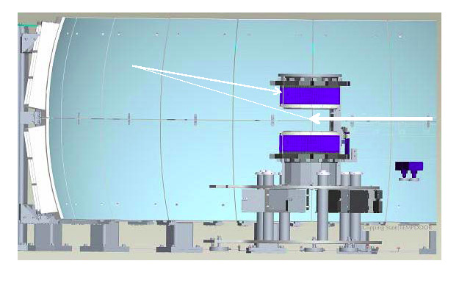
Figure 7. Schematics of scattered neutron trajectories Bragg-reflected from the crystal analyzer panels into the detectors. Note that the panels are split in the middle to preserve the energy resolution; hence, two detector banks with a gap in the middle.

The Solid Angle Variation for Each Pixel
Each pixel of the BASIS detectors accepts Bragg-reflected neutrons from a certain area of the crystal analyzer panels. In turn, such area accepts neutrons scattered by the sample into a certain solid angle, dΩ. The data reduction routine uses a pre-computed array of the solid angles associated with each detector pixel.

Analyzer Reflectivity and Detector Pixel Efficiency
As one can see in Figure 8, the distribution of the “raw” intensities shows that the pixels are not illuminated uniformly, even when a nominally “isotropic” sample such as incoherently scattered vanadium are used. Some variations in the intensities are expected, because of the (1) variations of the associated solid angles among the pixels and (2) possible variations of the pixels detection efficiencies. However, Figure 8 reveals the dominant role of the more systematic variations; namely, the scattering pattern approximately reflects the geometry of the analyzer crystal scattering panels; 9 two-dimensional intensity maxima in each the top and bottom detector banks correspond to the 9 panels in each the top and bottom banks of the crystal analyzer panels. Thus, while the correction for the solid angle can be computed and applied explicitly, the correction for the pixel efficiency of the detectors and the reflectivity efficiencies of the analyzers needs to be applied as a pixel-by-pixel division by the elastic line of the scattering intensity pattern obtained from an isotropically scattering sample, such as a vanadium standard.

Masking of Noisy Pixels
At users’ discretion, a mask can be applied to any group(s) of chosen pixels. For example, noisy pixels, or the pixels with intensities dominated by contributions from Bragg peaks, can be masked out. Such pixels are then disregarded by the data reduction routines.

.

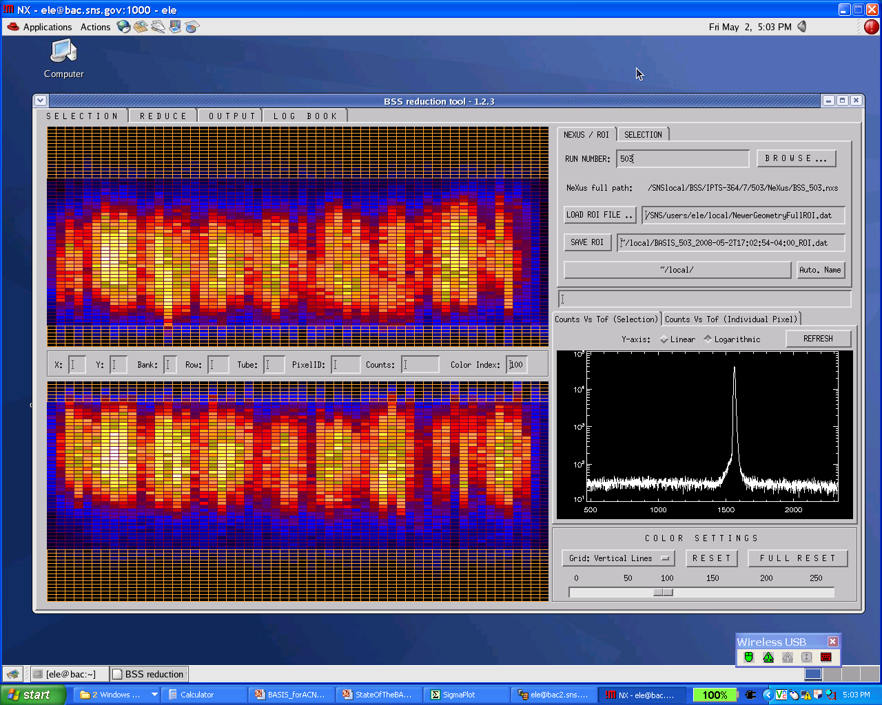
Figure 8. A typical snapshot of the BASIS data view for an isotropically scattering sample such as a vanadium standard.

A typical pixel view, as presented in Figure 8, consists of two dimensional colored intensity map that represent the pixilated total (summed over all TOF channels) intensities registered in the BASIS detectors. There are two detector banks, top and bottom, each consisting of 56 He-3 tubes. Each tube is a vertically pixilated linear position-sensitive detector; hence, two-dimensional intensity distribution. The plot on the right is the TOF signal summed over all non-masked pixels.

Section 5. Data Collection
Following sections of the manual assume that the sample hight has been adjusted and the sample is already in, and the secondary shutter is “ON”.

Setting up the instrument

BL2 BASIS Main Control
When starting an experiment at BASIS, to set up all the necessary variables, click on the dropdown menu at “Applications” and hover over to “DAS Tools” and click to “Staff CSS/CSS” (Figure 9a). You can even excess it by typing “css” in the terminal window and press ENTER (Fig 9b). The necessary applications to set up and run an experiment at BASIS (CS-Studio (Phoebus) will be launched (Fig 9 c).
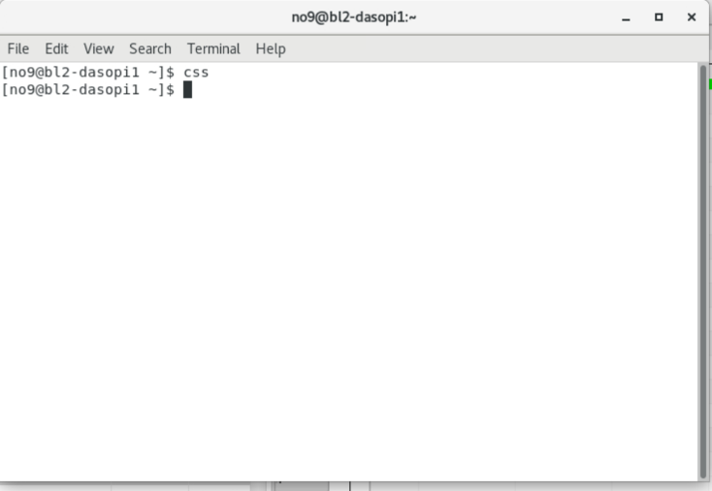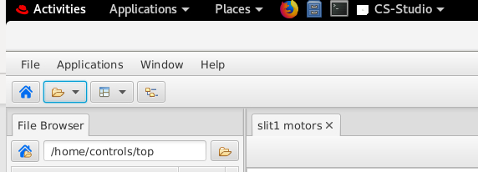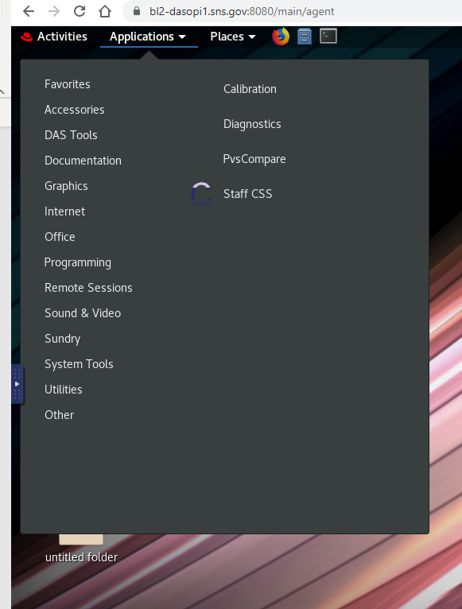
(b)
(a)
(c)

Figure 9. (a) and (b) Staff CSS/CSS. (c) CS-Studio (Phoebus)

Click the dropdown menu at “Top Resources” and select/click “Main” as shown in Figure 10 (a). It opens the “BL2 BASIS Main Control” window which is shown in figure 10 (b).

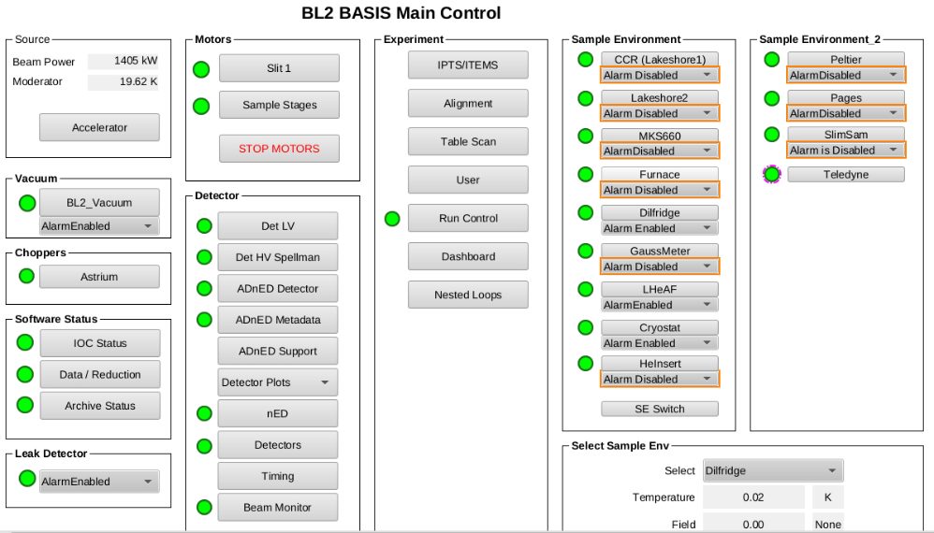
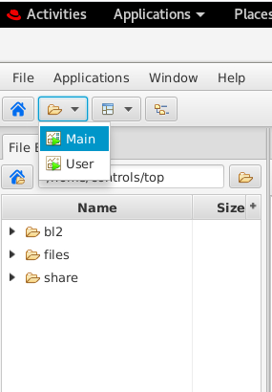
(a)
(b)
Top Resources

Figure 10. (a) Top Resources dropdown menu (b) BL2 BASIS Main Control panel

The Main Control Panel has all the options to control and set up an experiment. In most of the cases, icons themselves tell what we are going to accomplish after clicking them. Very first thing to do is go to “IPTS/ITEMS” under experiment to set up the correct IPTS number (Figure 11). From the list, select the right IPTS number. Once you select it, you should be able to see that IPTS number under proposal ID.
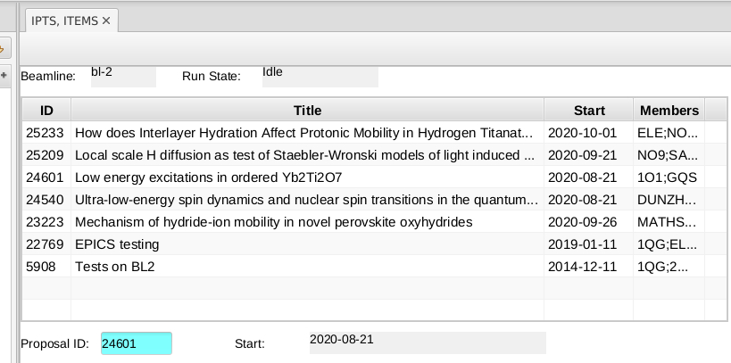
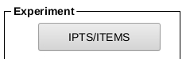

Figure 11. Selecting IPTS

To go back to the main control panel, click “open previous display” arrow from the top right corner as shown in Figure 12.

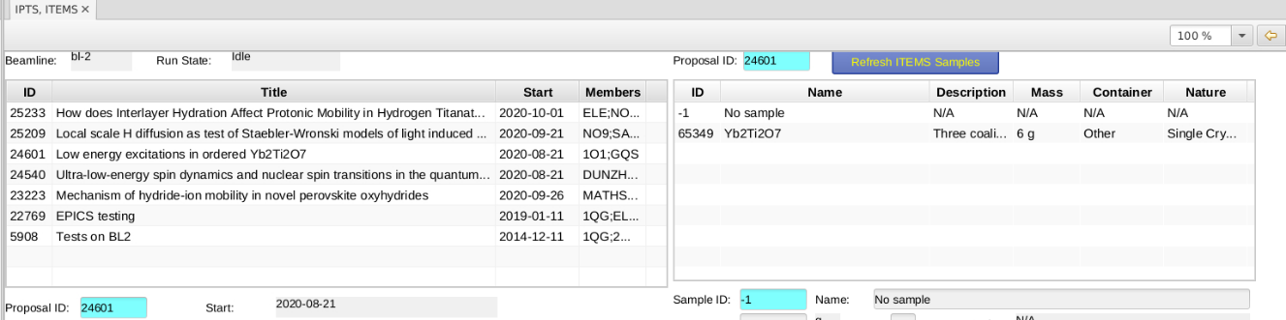
open previous display

Figure 12. Going back to main control panel

Choppers and Slits

BASIS offers several chopper operating modes to access different energy transfer ranges. Depending on the sample size and the type of sample cell used, motorized slits can be adjusted to optimize the neutron beam size. The chopper settings and the motorized slits can only be changed by instrument staff member; thus users are strongly encouraged to consult with their local contact and make the necessary arrangements at the beginning of the experiment.

All the other options available in the main control panel can be explored/used after consultation with the beamline scientists. Note that users are not allowed to touch anything under the “Detector” icon from the BL2 BASIS Main Control except the “Detectors plots” as shown in Figure 13. Detectors plots option allows you to select different detectors (elastic and inelastic) banks to look at to the data.
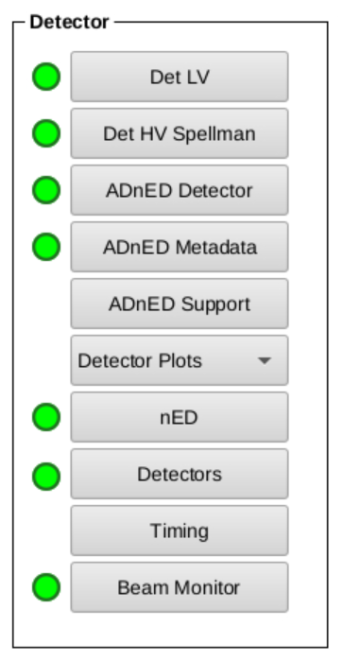
Figure 13. Access to the Detectors

Now you are ready to start your experiment. To start the experiment, go back to the main control panel and click “Dashboard” under experiment as shown in Figure 14. “Instrument Status” is displaced at the very top left corner in BL2 Dashboard as indicated by a red circle in Figure 14. Green horizontal bar represents the Beam Power and green circle indicates that both primary and secondary shutter are open. Dark green circle means either one, which is most likely the case, especially, the secondary shutter, or both shutters (primary and secondary) are closed.
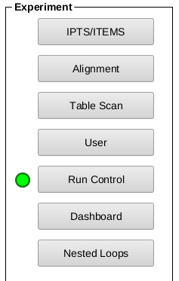
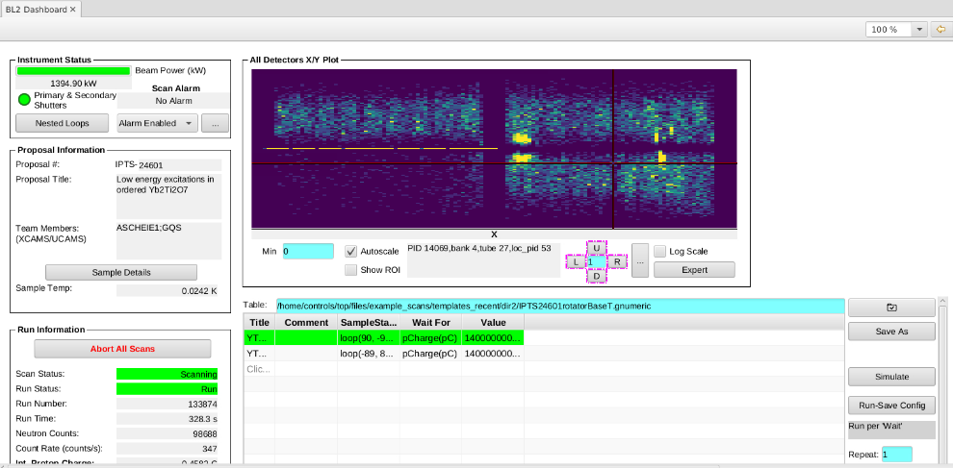

Figure. 14 User “Dashboard”

Tablescan
To set up a script for a series of measurements, a “gnumeric” file can be generated. Example scan files can be found under the sub-folder “dir1” within the folder “files” (see figure 15) on the left side of the CS-Studio.

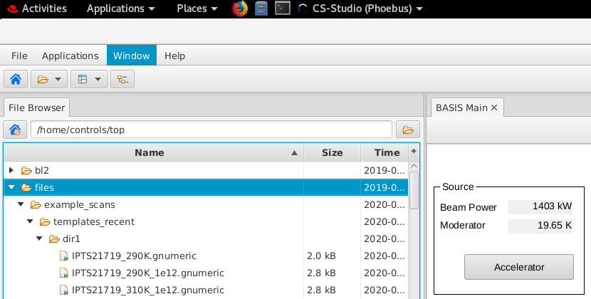

Figure. 15 Finding table scan script files for a series of measurements
Number of columns with different variables can be chosen to fulfill the requirements of the experiment. Below, in figure 16, those variables are:
- Title: You can put the name of the sample OR even keep it empty
- Comment: You can put any comment OR can be empty
- SampleTempSP(lakeshore): the temperature point request, in Kelvin.
- Delay, time (in seconds) to be waited before progressing with the measurement after the requested temperature within the given tolerance is reached.
- Wait For, choose to count for statistics (pCharge) or for time (s). Counting for equal statistics is preferred, since the source power is not constant all the time.
- Value, give value for certain statistics / time; when this value is reached, the measurement will progress to the next line in the table scan.

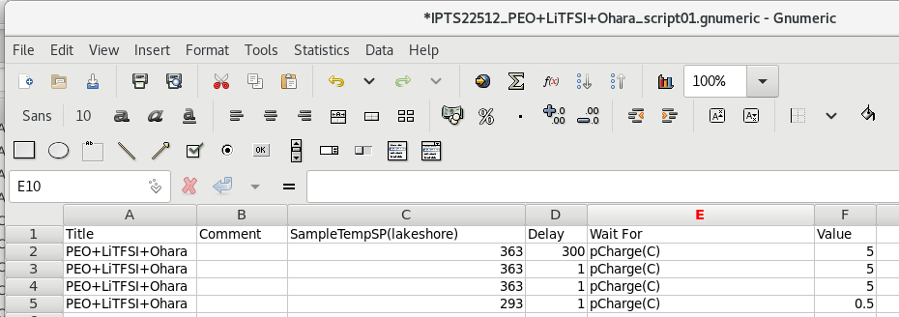

Figure 16. Tablescan to set script for number of measurements.

Note: This table scan can be different depending on the type of the sample environment chosen.

Once the table is created, it needs to be saved. To save the script file, go to “File” then to “Save as”. Give a new name to the file and click “Save” as shown in the figure 17.

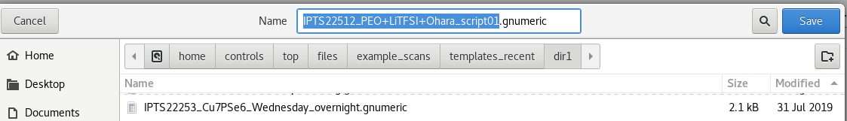

Figure 17. Saving a script file


The saved script file can be tracked and load to the “BL2 dashboard” using this
icon. Once you find and load the saved file, it will display on BL2 dashboard as shown in the figure 18.
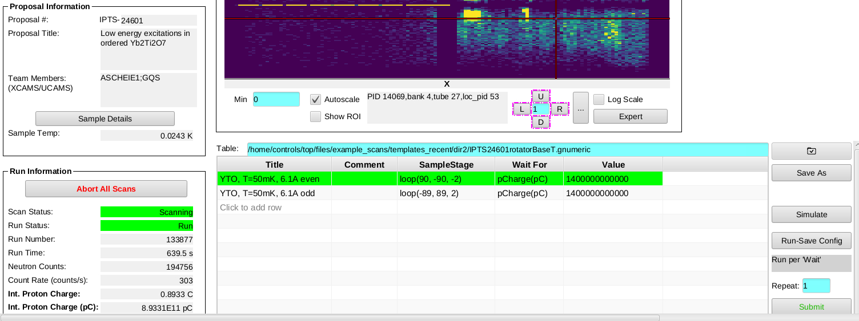

Figure 18. Loading script file.

Once the script file is loaded, you can hit “Submit” button to run the script. The line highlighted with green means that the line is currently running. You will see the information about that measurement under “Run Information” (Figure 19). Green highlighted lines mean that the script and the run both are running. If “Run Status” is highlighted in orange, it means, script is running but it might be waiting to meet other conditions requested on the script.
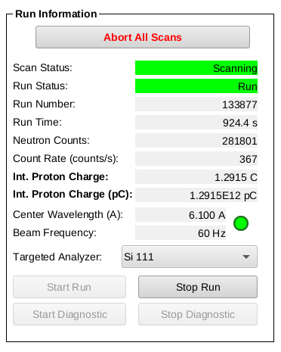
Figure 19. Run Information.

The script can be “paused” or “Stopped” using these two icons (Figure 20). Click the same pause icon to resume the script after you pause it.
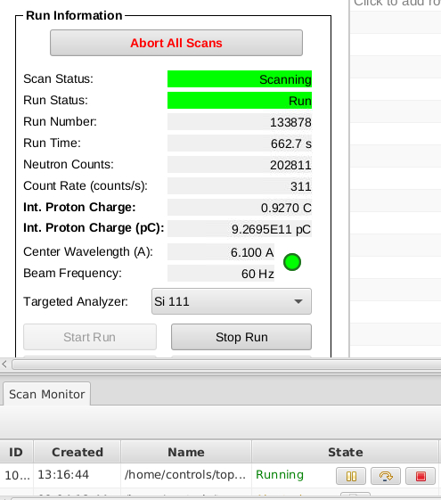
pause
stop
Figure 20. Stopping and Pausing the script

The instrument can also be run manually as well. To run it manually, first, “stop” the running script. Then, the “Start Run” icon will be enabled. Just click “Start Run”. Once you satisfy with the current measurement, click “Stop Run” to stop the run (Figure 21). The data will be automatically saved on your IPTS folder.

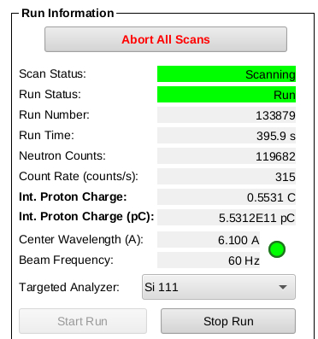

Figure 21. Running the instrument manually
Lakeshore
The temperature of the sample environment is controlled with the Lakeshore application at the BL2 BASIS Main Control window. Go to CCR (Lakeshore1) under sample environment as shown in Figure 22. The required temperature can be given in the temperature request field. If table scan option is used, the value for this field will be automatically communicated from the current given value at the table scan. The actual value can be typically read at the channel A, which is the closest measured point to the sample. The other channels show the temperatures at various points inside the CCR. You can also manually set the temperature of the sample at “Setpoint”.

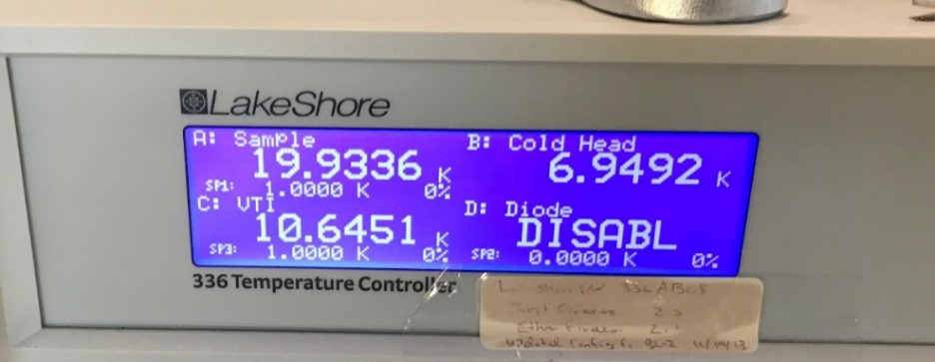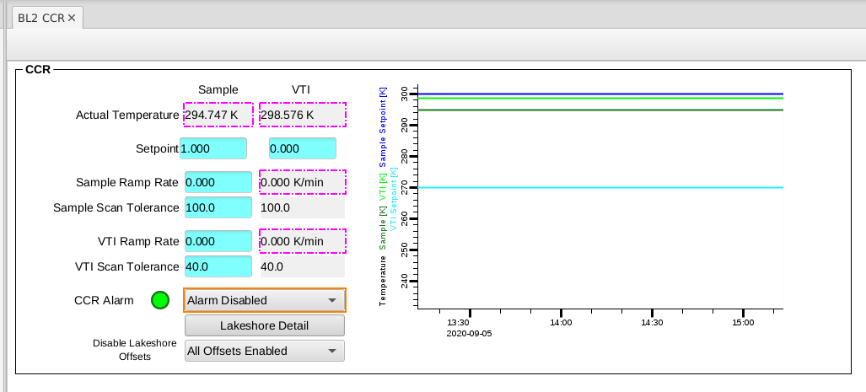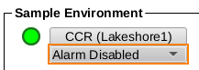

Figure 22. Lakeshore application to set temperature

Data Acquisition
When measurement is started, (either manually OR via script) the detectors banks (Figure 23) should show intensity at the quarters populated by the type of analyzers used for the current measurement. Each measurement will have associated run number, and the data will be stored automatically after each run is finished under the current IPTS number.

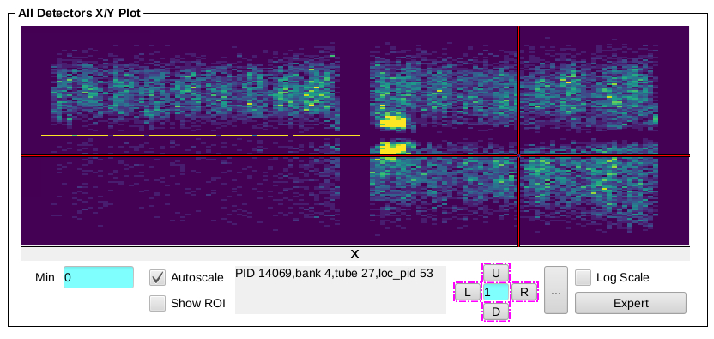

Figure 23. Detector banks at BASIS. The intensity in this case is distributed over the 3 quarters populated with the Si111 analyzers. The quarter without intensity (left side bottom) is covered with Si311 analyzers.

Besides the X/Y plot, Dashboard also displays “Beam Monitor Time Of Flight” and “Time Of Flight” spectra as shown in the figure 24. Make sure that “trapezoid” shaped Beam Monitor Time Of flight” spectrum is always there. Absence OR deviation from TRAPEZOIDAL shape means something is wrong. Contact the instrument hall coordinator (IHC) or your local contact, immediately.

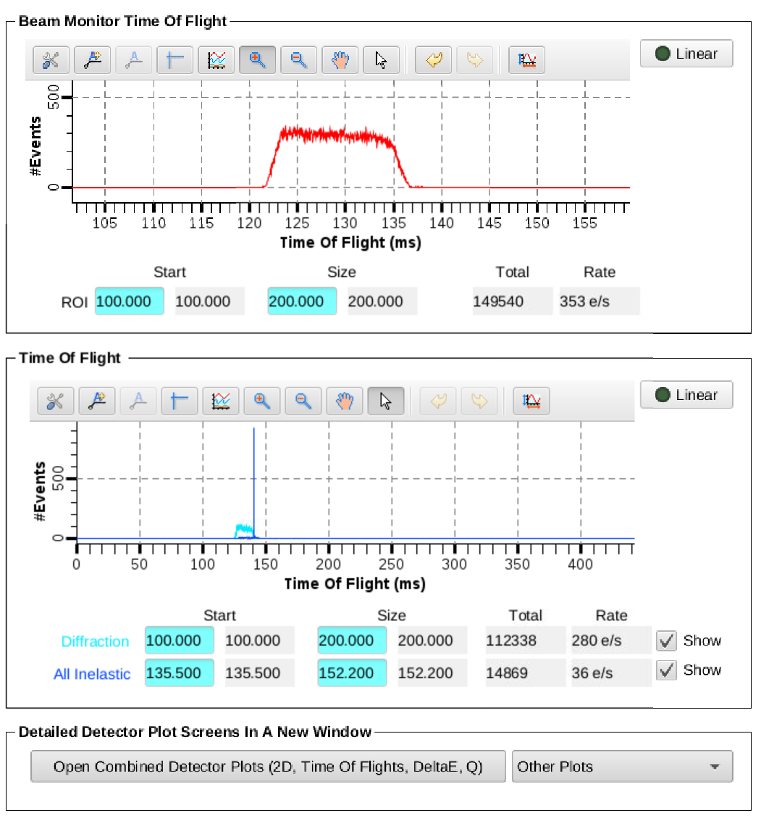

Figure 24. “Beam Monitor Time Of Flight” and “Time Of Flight” spectra

Section 6. Data Reduction
BASIS data can be reduced by using the bac or bac2 computers located at the BASIS control hut, or from other locations by connecting to analysis.sns.gov. BASIS users can login to these computers using their ucams or xcams accounts. When logged in, MantidPlot first needs to be launched.
Setup User Directory
To set up desired directory for reduced data, click the Manage User Directories symbol on the symbol bar (seventh from the left). A pop-up window will open allowing user to modify the save directory as wished (Figure 16). The input data will be automatically searched at the server.
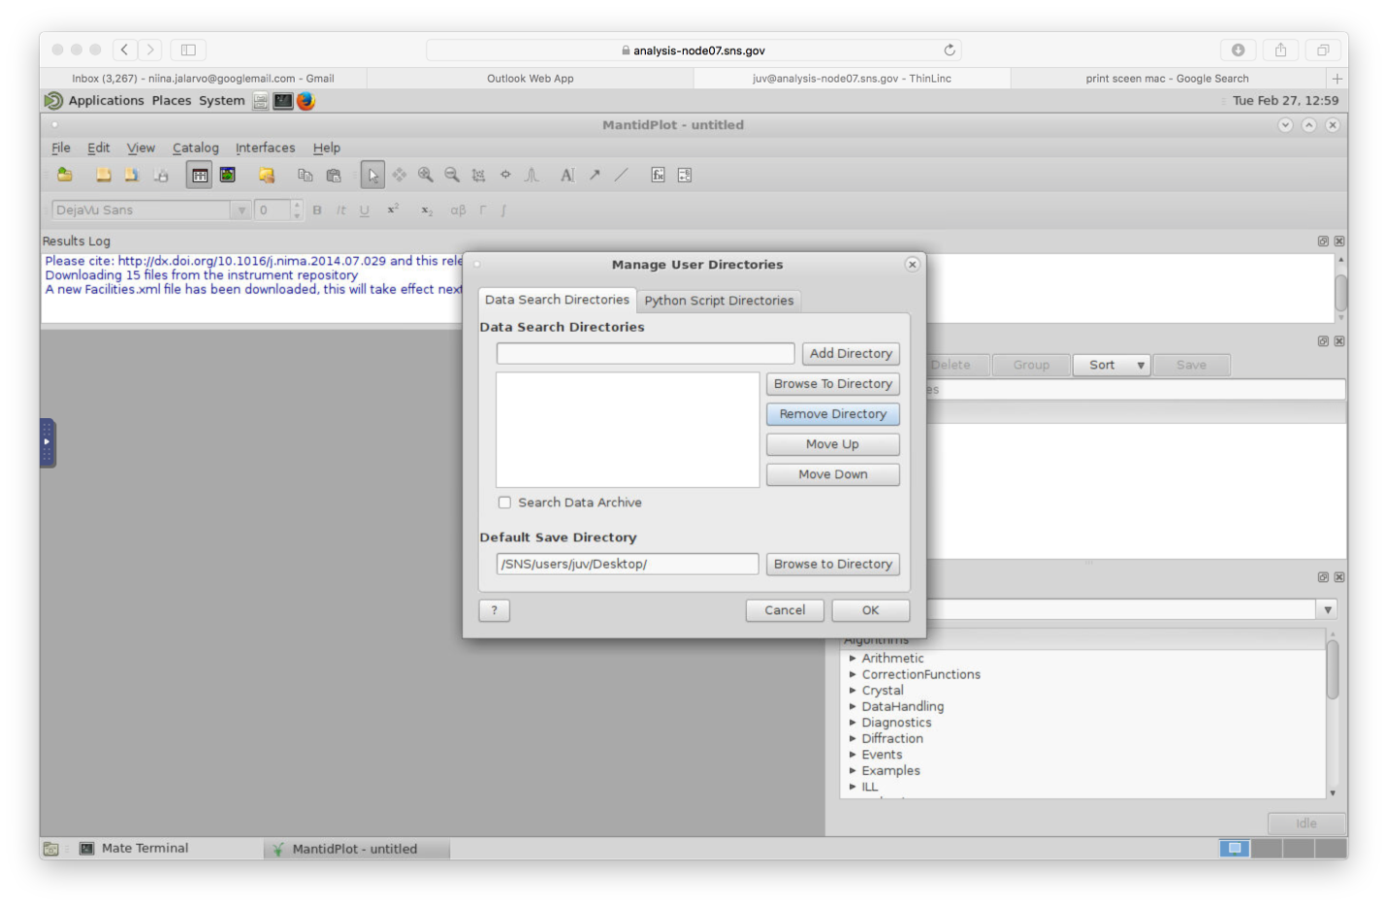
Figure 25. MantidPlot setup user directories.

BASIS data reduction
- To launch BASISReduction algorithm, type BASISReduction to the line next to the execute-button (right hand side on the middle of the window), then click execute. BASISReduction pop-up window will open (Figure 26).
- Fill in the run number or run numbers to be reduced. If several runs are to be reduced, there is an option to reduce them so that they will be merged to one output file. Alternatively, each one of them can be reduced separately and the data will be saved in separate files. In the latter case, choose the DoIndividual option right below the given run numbers.
- Then move to the Reflection Selector part. Choose the analyzer type that was used for the measurement, either Si111 or Si311.
  - For Si111 analyzer the EnergyBins should be set up from -120 to +120 using step size of 0.4 (-120,0.4,120). MomentumTransferBins are set the same way, first will be given the average of the lowest Q bin value, then the step size and then the average of the highest Q bin value. Typically, data is grouped to 9 Q bins, with bin width of 0.2 A⁻¹ (these values are displayed in Figure 18). Also, bin width of 0.1 A⁻¹ is often used if the statistics of the data allows. In that case the given limits, would be 0.25 and 1.95 to reflect the average value of the lowest and highest Q bin. Then the correct MaskFile needs to be chosen. Mask_default_111 can be used to Si111 analyzers, and Mask_default_311 can be used for Si311 analyzers. These files can be found under shared directory (BSS/shared/autoreduce/new_masks_08-12-2015).
  - For Si311 input values for EnergyBins would be (-740, 1.6, 740) and for MomentumTransferBins (0.4, 0.3, 3.7).
- When possible normalization by vanadium should be done. In this case, click the DividebyVanadium box, choose NormalizationType for by Q slice, and give the vanadium run number. If you did not measure vanadium, BASIS instrument staff member can provide the current vanadium run number for standard sample geometries.
- By clicking the run box on the bottom of the BASISReduction window, the data reduction will start. This will take some time, and when it is finished, reduced data files will be stored in the specified directory. Reduced data files will also appear in MandtidPlot as workspaces. Those can be viewed immediately (right mouse click the workspace and then choose plot spectrum).
- Data will be stored automatically in *.nxs and *.dat formats. The former is readable in MantidPlot, allowing also to visualize and work on the data within MandtidPlot. The dat format is a grouped ascii file, that has 3 columns (energy value, data point, error), and all the Q bins are written into these columns one after the other. This format is required by DAVE/PAN application that is often used to fit BASIS data at present time.
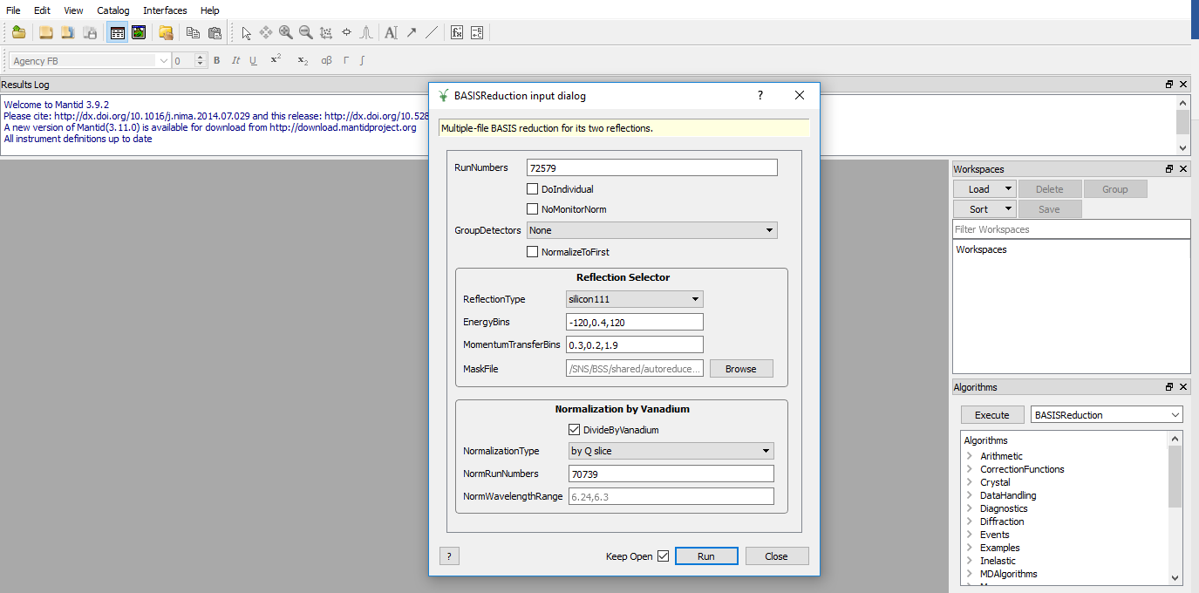
Figure 26. MantidPlot; launching BASISReduction algorithm. The reduction here is done for Si111 analyzers, and for 9 Q bins.

BASIS Diffraction data reduction:

BASIS is equipped with nine diffraction detectors installed between the south-top and south-bottom sections of the silicon analyzer panels. Although the Q-resolution is relatively modest (~0.1 Å⁻¹), BASIS simultaneously records diffraction data from each sample while collecting quasielastic neutron scattering (QENS) data. In most cases, prior characterization of the samples reveals whether structural (Bragg) peaks are present within the Q-range accessible to BASIS. However, for newly synthesized or previously uncharacterized samples, careful examination of the diffraction patterns collected during the BASIS measurement can help identify contamination of the QENS signal by coherent scattering arising from Bragg peaks.
Follow the steps below to reduce powder diffraction data using the BASISPowderDiffraction algorithm in Mantid (Figure 27):
- In the field next to the Execute button (on the right-hand side of the Mantid interface), type BASISPowderDiffraction and click Execute. The BASISPowderDiffraction dialog window will open (Figure 17).
- Enter the run number of the data set to be reduced.
- Check the DoFluxNormalization option.
- Leave the MomentumTransferBins parameter at its default value:
  - 0.2, 0.0025, 2.0
- Enter a name for the output workspace in the OutputWorkspace field.
- Specify the mask file in the MaskFile field using the following path:
  - SNS/BSS/shared/autoreduce/new_masks_08_12_2015/BASIS_Mask_default_diff.xml
- Enable vanadium normalization by providing the appropriate vanadium run number. If you did not measure a vanadium standard during your experiment, a BASIS instrument staff member can provide the appropriate vanadium run number for the standard sample geometry used.
- Click Run at the bottom of the BASISPowderDiffraction window to start the data reduction.
- After the reduction is complete, the output workspaces will appear in the Mantid Workspaces panel. To view the reduced diffraction pattern, right-click on the desired workspace and select Plot Spectrum.
- The reduced data are not automatically saved to your output directory. To save the data:
  - Launch the SaveAscii algorithm.
  - Select the workspace you wish to save.
  - Browse to the desired output folder.
  - Save the file in ASCII format.
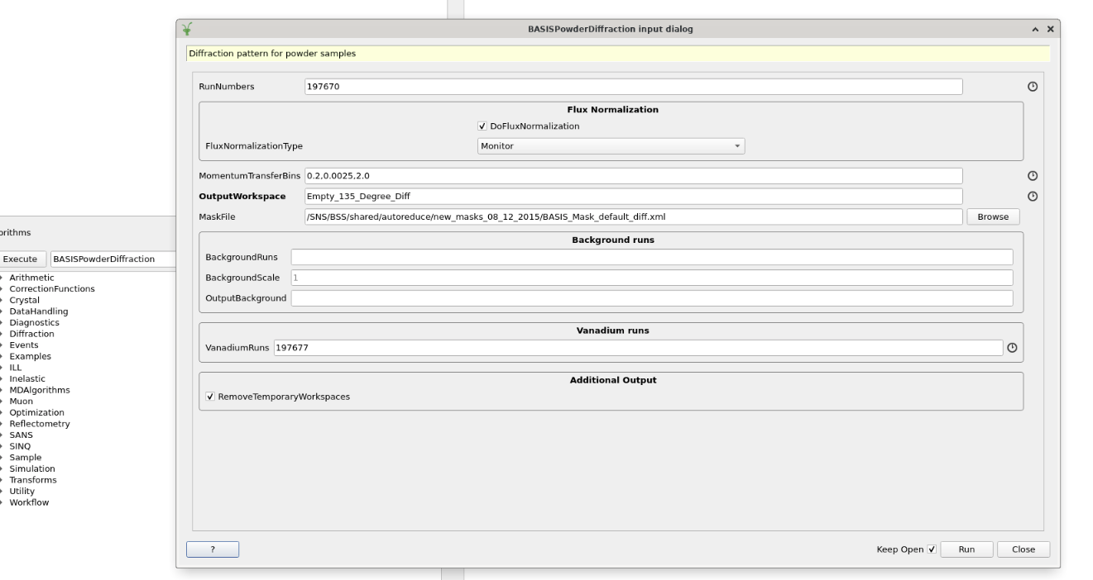
Figure 27. MantidPlot; launching BASISPowderDiffraction algorithm

Section 7. Data Output Formats
The standard output of the BASIS data reduction routine is a file compatible with the 3-column ASCII format used by the DAVE reduction software (energy transfer, intensity, intensity error) and QClimax. If the data are binned to more than one Q bin, the file format is known as DAVE Grouped ASCII (1 column of data for the energy transfers (same for all Qs), then 1 column of data for the Q values, then 2 columns of data for the intensity and intensity error for each Q value or “Group”, beginning with Group 0, which corresponds to the first Q value). Note that DAVE may experience problems with loading a file that has a Grouped ASCII format, yet possesses only one Q bin. In such case, even if the data are intended to be reduced using just one Q bin (e.g., for the BASIS all-inclusive (in QENS regime) Q range of 0.2 Å⁻¹ < Q < 2.0 Å⁻¹, for which - - mom-trans-bin = 0.2, 2.0, 1.8 command is utilized), users may add, for the sake of getting the output data loaded to DAVE quickly, a second, “dummy” Q bin (e.g., 0.2 Å⁻¹ < Q < 2.0 Å⁻¹ and 2.0 Å⁻¹ < Q < 3.8 Å⁻¹⁻, for which - - mom-trans-bin = 0.2, 3.8, 1.8 command is utilized). It should be noted that not all versions of DAVE would accept a file containing one or more nan (not a number) values.

Appendix. Bragg reflections from the crystal analyzer panels.

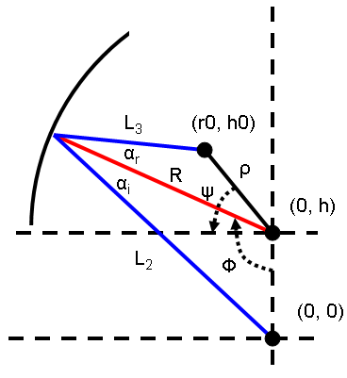
- , rCylinder - The radius of the cylinder that the detectors are on.
- , rSphere - The radius of the sphere that the analyzer crystals are on.
- , sphereOffset - The vertical offset to the focal point of the analyzer crystal.
- , cylinderOffset - The vertical offset of the detector center.
- , h0 - The position (height) of the pixel in global coordinates.
- , phi - The angle of elevation of the radius vector to where the neutron is scattered on the surface of the analyzer crystal measured from the negative y-axis.
- , psi - The angle between the detector pixel position vector and the horizontal.
- , alpha - The angle of reflection on the analyzer crystal measured from the surface normal.
- , alphaI - The incident angle of reflection on the analyzer crystal measured from the surface normal.
- , alphaR - The reflected angle of reflection on the analyzer crystal measured from the surface normal.
- , xOffset - The arc position () of the pixel in the local x-coordinate.
- , yOffset - The position of the pixel in the local y-coordinate.
- , thetaD - The angle from the pole of the detector pixel constrained in the scattering plane.
- , rho - The distance from the sphere center to the detector pixel.
- , wavelength - The wavelength of the scattered neutrons.
- , wavelengthOffset - Scale parameter of the scattered wavelength. It is the wavelength of the neutrons selected if they are scattered normal to the scattering plane.
The parameter is described by
- 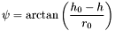
while the parameter is
There are three values that all other information depends on. They are the secondary flight path (distance), polar angle, and azimuthal angle. The equations for these three entities are:
- 
- 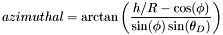
In the equation for distance L2, the distance from sample to analyzer crystal, is calculated using
L3, the distance from analyzer crystal to detector, is calculated using
The wavelength is calculated according to
Where is calculated (the two alphas should be identical):
The incident angle of reflection is
- 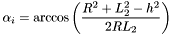
The reflected angle of reflection is
- 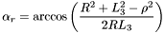
The goodness of fit, the criteria for determining the value of is
A 'good' value of phi is found when this is zero.

