POWGEN User Manual for Data Reduction:

This document contains a detailed description of how to access and reduce POWGEN data, including how to slice out data by time, temperature, or other logged parameters. Data may be reduced using our analysis machines, either on-site via powgen (powgen.sns.gov) and powgen2 (powgen2.sns.gov), or outside ORNL via the analysis cluster.

Accessing Data:

- Go to the user portal and create an XCAMS ORNL Resource account (if you don’t already have an account). This is the same as the account for the IPTS system.
https://user.ornl.gov/Account/Login.aspx
If you have forgotten your password, go to https://user.ornl.gov/Account/Login and you will be able to retrieve your password by using the “Forgot your password?” link.
- To connect to the analysis cluster, go to http://analysis.sns.gov/ (Figure 1).
  - To use the web-based client in your browser, click the “Launch Session” button. You may also go directly to https://analysis.sns.gov:8080. Login with your XCAMS username and password.
  - Alternatively, you can install the Thinlinc client on your machine. Click on the Thinlinc button and follow the steps to install and configure the client (Figure 2). Login credentials will be the same as XCAMS.
Web client
Thinlinc client
FTP
SSH
Figure 1. Access the analysis cluster by going to http://analysis.sns.gov and either clicking "Launch Session" or installing the Thinlinc client.

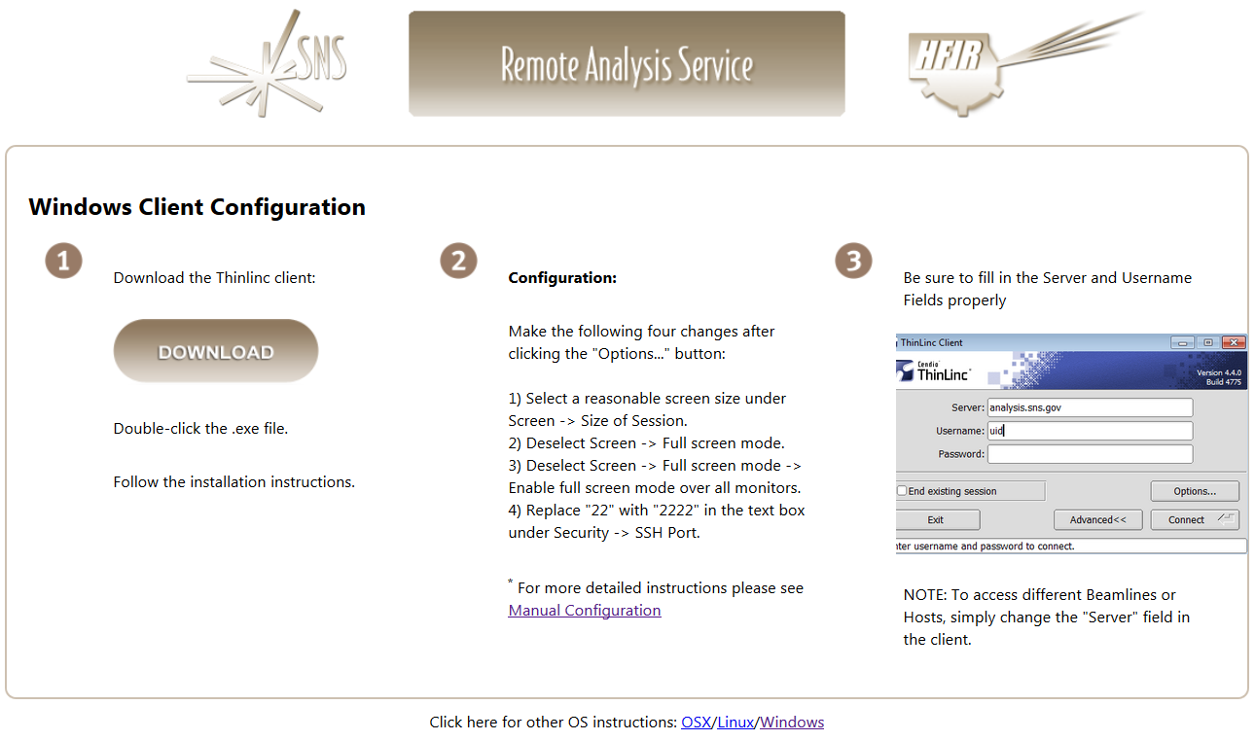
OSX and Linux instructions
Figure 2. Thinlinc client installation instructions are available at https://analysis.sns.gov/instructions/windows.html .
- Once you login under your home directory you will see the following folder structure /data/SNS/PG3/IPTS-#/. If you fail to see the IPTS-# folder then try /SNS/PG3/IPTS-#/shared/autoreduce. This is the real location of the file whereas the first one is a symlink. All the run numbers will appear for your data.
Data is automatically reduced to GSAS, FullProf and Topas files using the default parameters. Those data can be found in the /shared/autoreduce folder. You can of course re-reduce data with other binning values using mantidplot.
Extension .gsa for GSAS: Files are numbered with banks which correspond to the wavelength used. Please use the corresponding bank number from the parameter files for refinements.
Extension .dat for fullprof: The data file names themselves tell you which bank they are and the same bank IRF file should be used.
Extension .xye for topas: Again, the data file names themselves tell you which bank they are. For example, PG3_24759-2.xye is run number 24759 collected with bank 2.
- Secure ftp or secure shell will allow you to get the data onto your local drive. Two such programs can be downloaded from http://cyberduck.io/ or http://filezilla-project.org/download.php?type=client. Enter the following information to connect to the analysis computers:
Host: analysis.sns.gov
XCAMS username and password
Port: 22
- Parameter files for GSAS and IRF files for Fullprof can be downloaded from the table titled “Data Reduction and Analysis by Run Cycle” on the Powgen website http://neutrons.ornl.gov/powgen/users. There is also a Topas template file with the appropriate parameters. Be sure to pick the correct cycle.

These files are also stored on the analysis computer in /SNS/PG3/IPTS-2767/shared/cycle_11A_CAL, where cycle is year_1 (for cycle A) or year_2 (for cycle B). For cycles before 2014B, the cal folders are stored in /SNS/PG3.

The parameter and IRF file names contain HR or HI to denote whether High Resolution or High Intensity mode was used for data collection. If the guide value is -56.863 in your summary file, then the data were collected using HR, while if the value is 162.645, then the data were collected using HI guide.

- A summary file called PG3_IPTS-#_runsummary.csv, which is a csv file with all relevant information about the runs (e.g. sample temperature), is available. It can be found in the /SNS/PG3/IPTS-#/shared/autoreduce folder.

Data Reduction:

All data is reduced using a program called MantidPlot (Figure 3). Type “mantidplot” in a terminal window on either the analysis cluster or on the local analysis machines to start the program. If this is your first time, pull down the menu at the start button , go to System Tools and make a shortcut for a terminal on the desktop or launcher panel by right-clicking.

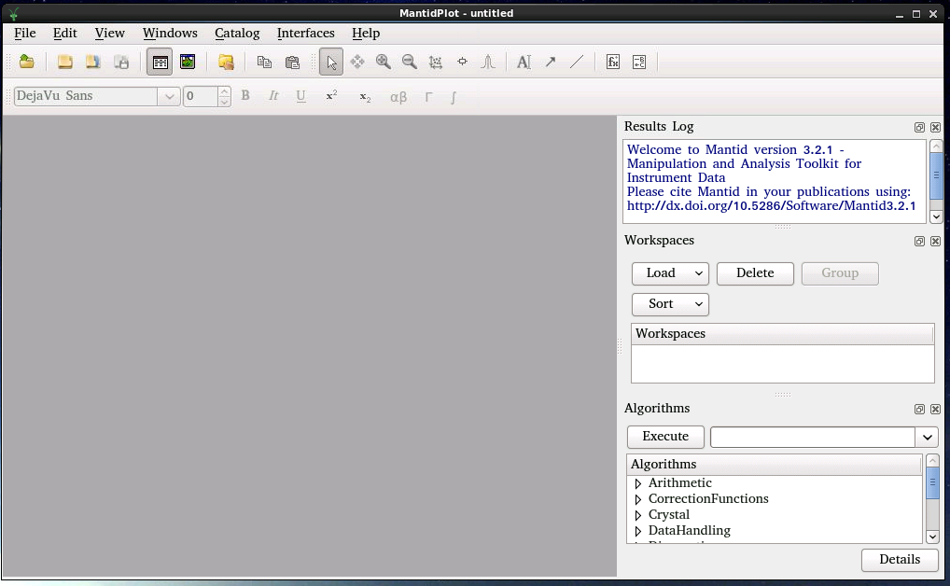
Figure 3. Mantidplot interface.

Data are automatically reduced into gsas, fullprof and topas formats. If you want to rebin the data (different from what autoreduce creates) or do some special subtraction of background, you can reduce the data using MantidPlot. In the Algorithms panel type in “SNSPowderReduction” and hit return or click Execute (Figure 3). This will launch the script (Figure 4). Once the fields are all specified, hit Run to reduce the data. Fields to enter in this script are as follows.
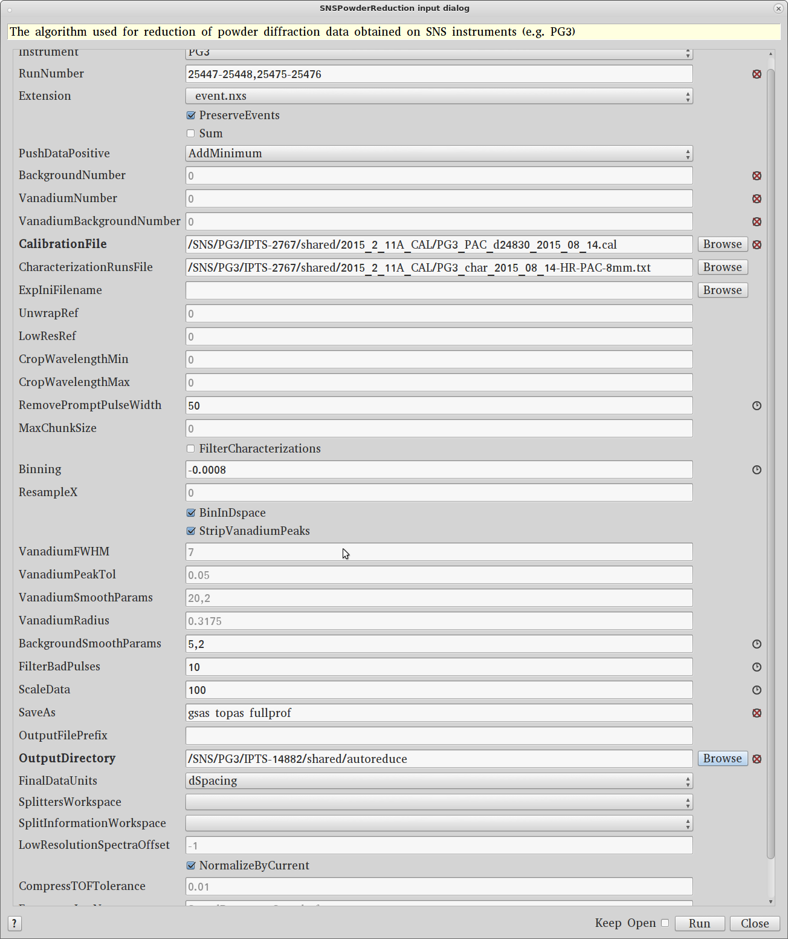
Figure 4. SNSPowderReduction algorithm settings.

SNSPowderReduction:
- Instrument : PG3
- RunNumber: This can be a single number or a range of numbers separated by hyphen ‘-‘. Multiple ranges can also be entered via comma separation. For example “2300-2350, 2355, 2360-2365” is a valid entry. When the Sum box is checked, all the runs will be summed together. When the Sum box is not checked, each run will be reduced separately.
- PushDataPositive: If due to subtraction, the counts go negative it will add a constant value to the spectrum so that all counts are positive (AddMinimum) or reset those negative numbers to Zero (ResetToZero) or do nothing (None).
- BackgroundNumber and VanadiumNumber should be added only if you chose to not use the default run numbers set in the CharacterizationRunsFile. In this case, time min and time max have to be included in the binning field, along with the bin width. If you enter -1, the algorithm will ignore the characterization file. This is a good way to generate a raw file without normalization and background subtraction.
- CalibrationFile: This data is stored in the folder: SNS/PG3/cycle_11A_CAL and has an extension .cal, for example the calibration file for run cycle 2011B is SNS/PG3/2011_2_11A_CAL/PG3_FERNS_d4832_2011_08_12.cal.
- CharacterizationRunsFile: This is a simple text file, found in the same folder as the calibration file, that lists all the instrument standard Vanadium and Background data collected. Choose the appropriate characterization file for the sample environment and can size used.
- LowResRef: This should be left empty starting cycle 2013B.
- RemovePromptPulseWidth = 50
- Binning: This is the bin width. For linear binning, enter a binwidth in microseconds for time or angstrom for d. For logarithmic binning enter a negative sign before the value of δt/t. “-0.0006” is a good starting point and works for most datasets. However, users can choose this value based on what is needed for their individual samples.
- The next several fields are associated with cutting out the V peaks and a smoothing operation and should be left empty (default).
- BackgroundSmoothParams: To apply smoothing to the background run. 5,2 works best for V cans.
- FilterBadPulse = 10. This takes out any background collected during accelerator faults and down periods.
- ScaleData: Some Rietveld programs have problems with plotting tick markers if the data is too close to the zero base line. By default (autoreduction) we multiply by 100.
- SaveAs: Available file formats are gsas, fullprof, topas, pdfgetn and processed nexus.
- OutputFilePrefix: If the Sum box is checked to sum multiple dataset, this allows the user to specify the file name for the summed dataset.
- OutputDirectory: Directory in which the reduced file should be saved. Users can Browse to select desired location

Slicing data by slow control log values or time:

In the main menu pick InterfacesDiffractionPowder Diffraction Reduction (Figure 5).

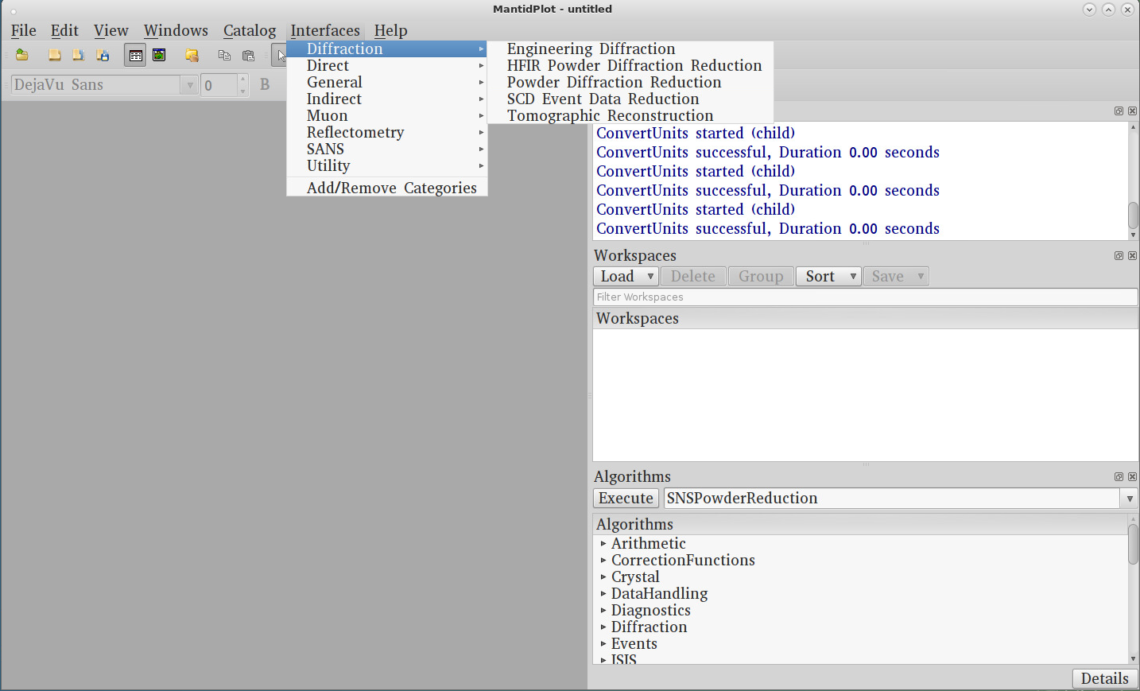
Figure 5. Opening the Powder Diffraction Reduction window for data slicing.

This will launch the following window (Figure 6 & 7). Most of the inputs are identical to the ones used in SNSPowderReduction.

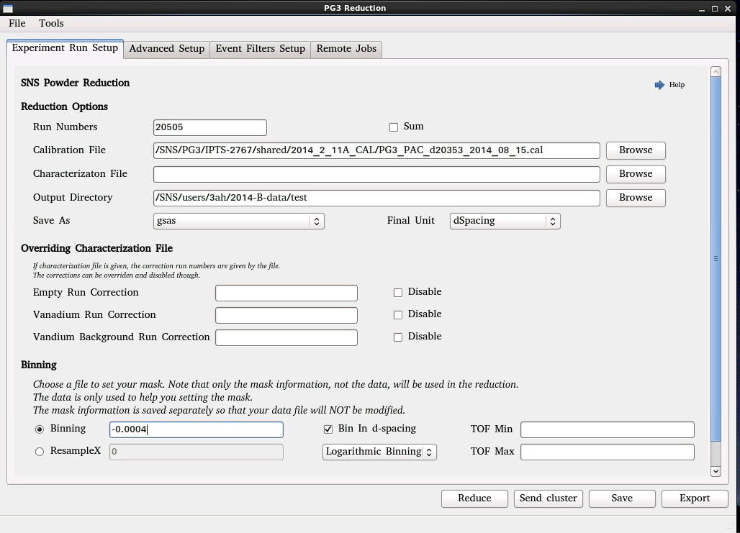
Figure 6. Main tab of the Powder Diffraction Reduction window.

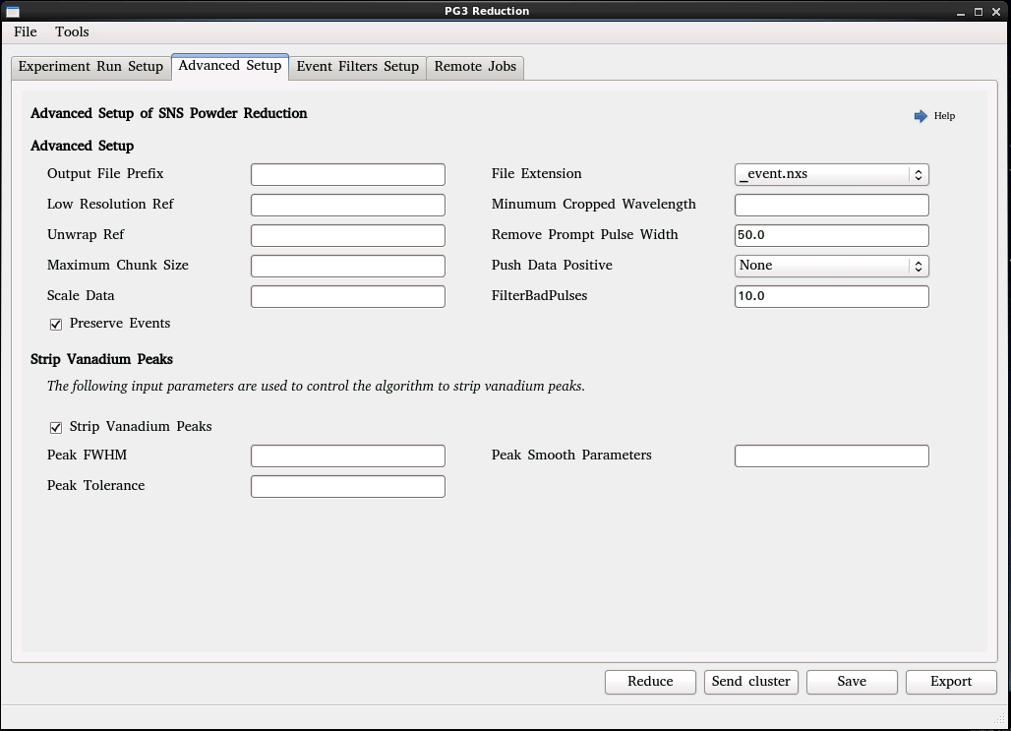
Figure 7. Advanced Setup tab of the Powder Diffraction Reduction window.
You will need to use the tab titled Event Filters Setup (Figure 8) to setup the required slicing. You have various options to slice by time or by log value, e.g. temperature.
The first option is to slice out a portion of the data by time (in seconds). ‘Filter by time’ will take the data and create a series of datasets with the time interval specified.
‘Filter By Log Value’ allows data to be sliced by any logged value embedded in the raw data. The ‘Filter Generator Assistant’ loads a Nexus file and allows the user to view what is being logged and plot individual variables. Most commonly, sample temperature is the variable of interest. The Log Name to use varies with different sample environment temperature controllers – use the assistant to determine the correct one for the desired file.
Select the desired options. Be aware that the minimum and maximum output may not be what is intended, so check the sample logs of the generated workspaces to check if they are correct. For example, using a step of 5K using a centre log boundary with a minimum of 10K can produce a first file with T_{min} of 7.5 and T_{max} of 12.5, even if no data exists below 10K. The datafiles produced will have _1, etc. appended to the run-number in order of increasing temperature (not time). Currently, the intensities in the datafiles produced by slicing are not renormalized by proton charge correctly, so they may need to be rescaled (using the Mantid algorithm Scale) for comparison or an appropriate value for scaling used in the Advanced Setup pane.

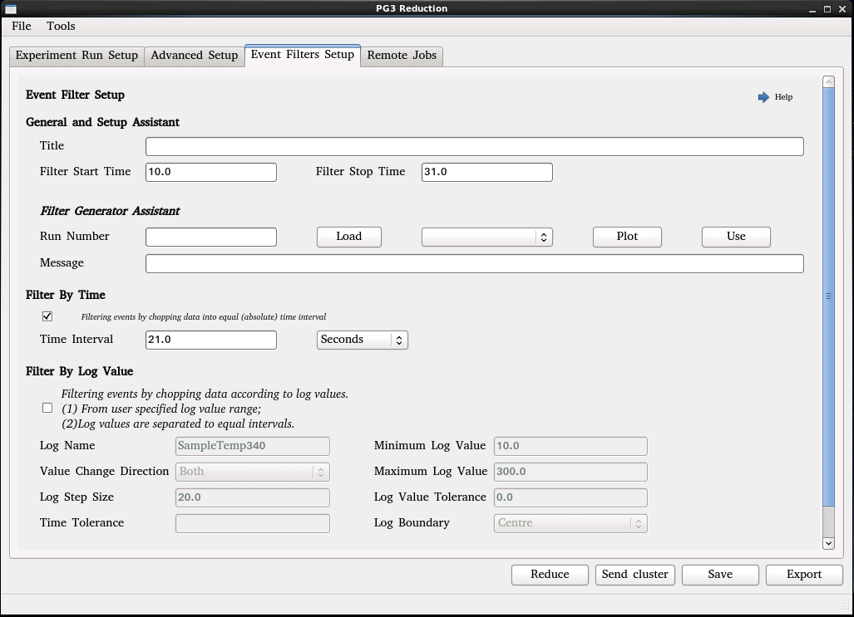
Figure 8. Event Filters Setup tab of the Powder Diffraction Reduction window.
If you right click on the workspace that is created, you can do various different types of plot. Once the data is reduced you can also see all the logs e.g. temperature, chopper, etc. and plot them by right-clicking the workspace, selecting Sample Logs, and double clicking the field.

Other useful commands:

Other useful commands are below. In the Algorithms panel type in the following commands and hit return or click Execute.
- LoadGSS: This will load a GSAS file, plotted as a function of tof.
- ConvertUnits: To change the x-axis, e.g. to d-spacing.
- LoadMultipleGSS: Here a series of runs can be specified and plotted as a function of d spacing.
- ConjoinFiles: This will joins into one workspace multiple runs, all of which must have the same wavelength. By right-clicking on the workspace, a 2D color fill plot may be made.
- LoadEventNexus: To look at any recorded log value (e.g. sample temperature), load the Nexus raw data file. Make sure to check Load Logs.

Many other algorithms are available and to learn more go to the Mantid website.

http://www.mantidproject.org/Main_Page

