HB-3A DEMAND Data Reduction Tutorial Using ReTIA
Written by Y. Hao, Ver 2025.1
- Access MATLAB and ReTIA:
The HB-3A data reduction uses ReTIA, a MATLAB package. To access ReTIA, log on to the analysis server at analysis.sns.gov and open MATLAB by ApplicationsAnalysisMATLAB (any version):
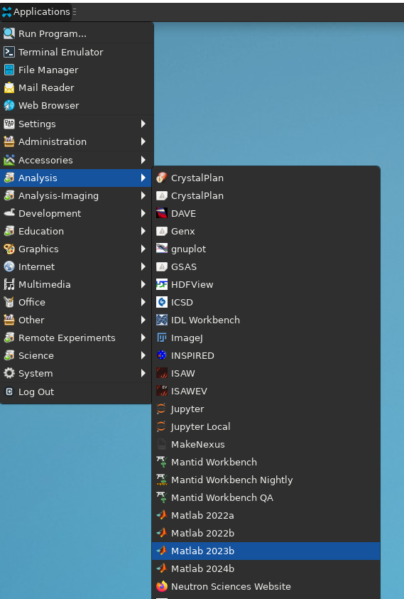
In MATLAB, first go to Preferences, then go to KeyboardShortcuts, set the active settings to Windows Default Set. This step will enable the Windows-type hotkeys such as Ctrl+C/V.
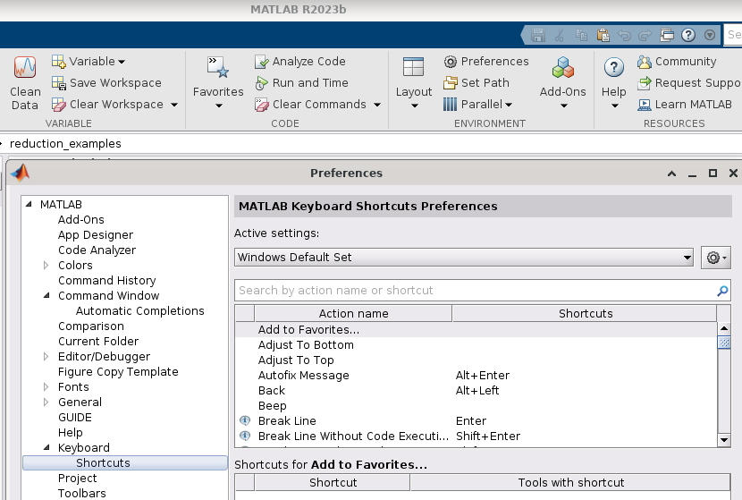
Set the working dictionary to the IPTS shared folder: /HFIR/HB3A/IPTS-xxxxx/shared. It is highly recommended to create a new folder under shared/:
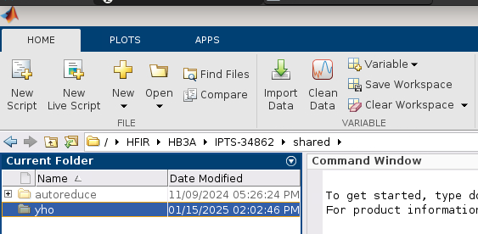

Open the newly created folder, type in Command Window: copyfile('/HFIR/HB3A/shared/yho/reduction_examples/reduce_HB3A_four_circle.m')
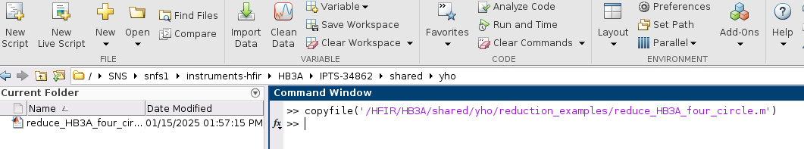
This will copy the example reduction script to the current folder.
Open the file to edit:
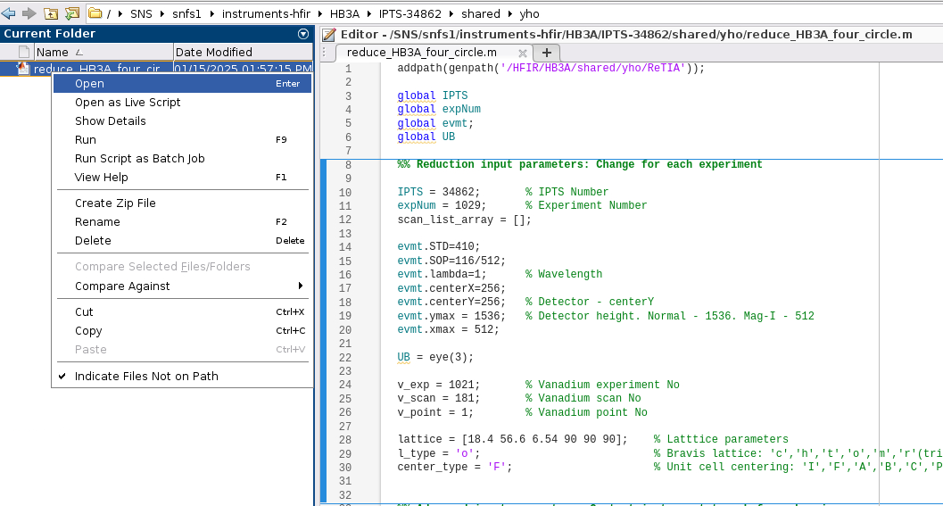
1. Edit the reduction script
The reduction script is written in 7 sections:
Section 1 – Initialize
Section 2 – Basic Input Parameters (user need to edit this part)
Section 3 – Advanced Input Parameters
Section 4 – Data Loading
Section 5 – UB-matrix Searching
Section 6 – Nuclear peak reduction
Section 7 – Magnetic peak reduction

MATLAB will by default run all sections by their order. It can also run each section individually. 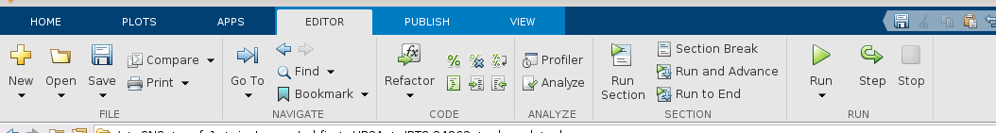

In principle, user would only need to modify the 2nd section, starting from Line 11:
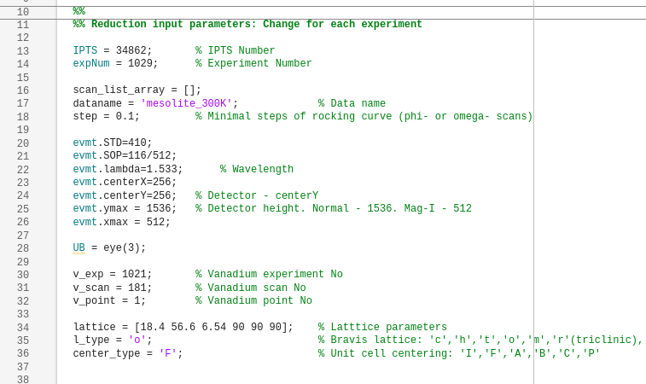

Line 13-18 are input/output parameters
Line 13-14, IPTS and experiment Number.
Experiment number is given at the start of experiment. Can also be found at OnCat (Oncat.ornl.gov)
Line 16, Scan List.
The user needs to specify in 1-D MATLAB array which scans to reduce.
Examples: scan_list_array = [1,2,5:7,10:2:14] will reduce scan No. 1, 2, 5, 6, 7, 10, 12, 14
Scan numbers can be fast reviewed at OnCat (oncat.ornl.gov)
Line 17, Output file and folder name. User-defined.
Recommended naming strategy is sample_condition, e.g. ‘RTsuperconductor_298p5K_0T’
The author advice to avoid using ‘.’ In filename.
Line 18, Rocking-curve scan steps.
This is the minimal step of long mapping scans, if some scans can be combined, they will be combined to this minimal step value. Single peak scan will not be affected. Default value is 0.1, which works for 0.1, 0.2, 0.3, … degree step scans.
Line 20-32 are instrument parameters.
Line 22, neutron wavelength.
If more than one wavelength were measured, a separate script is needed for each wavelength.
Line 24, Detector center-Y.
In four-circle mode, use Y = 256. In two-axis mode, this is measured during the alignment.
Line 25, Detector height.
Use ymax = 512 if the experiment used cyromagnet (Mag-I), otherwise use ymax = 1536.
Line 30-32, Vanadium run numbers.
Ask the local contact which vanadium run should be used.
Line 34-36 are crystal lattice information.
Line 34, lattice parameters
defined in [a, b, c, alpha, beta, gamma]. Starting value of the lattice fitting iteration.
Line 35, Bravis lattice type.
One-letter code. It decides how lattice parameters are constrained in the fitting iterations.
Defined as: cubic, hexagonal, tetragonal, orthorhombic, monoclinic, and triclinic
For rhombohedral cell, use ‘h’ here and the hexagonal lattice parameters in line 33.
Using low symmetry for a high symmetry cell can still have a valid reduction, but with slightly distorted lattices.
Line 36, Unit cell centering.
One-letter code. The script will only reduce the centering condition allowed Bragg peaks.
First letter of the space group. Allowed inputs are: ‘P’, ‘A’, ‘B’, ‘C’, ‘R’, ‘F’, ‘I’.
Using ‘P’ for a centered cell will still have a valid reduction, but with more zero-intensity peaks.
2. Running the reduction
After above modifications are made, Save (Ctrl+S) the script and Run (F5) it. Note: the working directionary should be the folder consisting the reduction script.
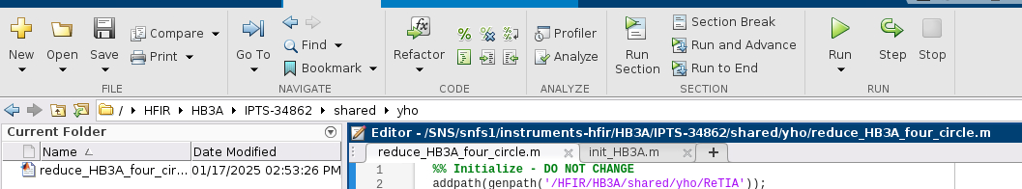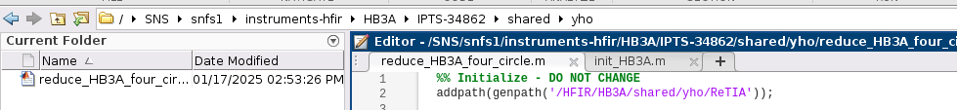
Either of the two dictionaries is possible, and they are both correct.
A normal run would include:
- Loading scans
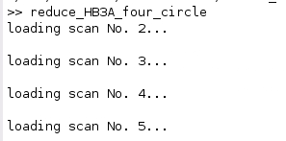

After loading scans, a cut structure is created in the MATLAB workspace. It includes the combined information of all scans in the list provided by user (see Line 16).

- Peak searching
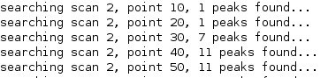
After peak searching, a pklist structure is created in the MATLAB workspace. It includes the searched strong diffraction peaks in the cut dataset

- UB-matrix iteration
After UB-matrix iteration, a UB_pool structure is created in the MATLAB workspace. It includes the most possible UB-matrices and each of their lattice parameters with standard errors.

- Peak integration
After Peak integration, a pklist_gene structure is created in the MATLAB workspace. It includes all k=0 Bragg peaks found by UB in the cut data coverage.

- Peak fitting
After Peak fitting, the peaklist_gene structure is updated to have integrated intensities. And an filename.int (see line 17) file is created in Fullprof format.
3. Viewing the results
The peak reduction results are shown in the peaklist_gene structure.
The UB matrix, lattice parameters and possible domain information are found in the UB_pool structure.
The screenshots of the peak integration and fitting are found in the [dataname]_gene and [dataname]_fit folders, respectively.
The integrated intensity (Fullprof format) is listed in the [dataname].int file.

HB-3A DEMAND Data Reduction Tutorial Using ReTIA – advanced level
Written by Y. Hao, Ver 2025.1
Disclaimer: This advanced tutorial assumes the reader has some understanding in crystallography in general and is comfortable typing commands into MATLAB.
0. Commands in ReTIA:
ReTIA offers some useful commands for single-crystal diffraction experiment. Including:
UB = Bmatrix( [a, b, c, alpha, beta, gamma] )
writeScan
int_twin
output_peaklist (scale factor)
output_peaklist_inc
XYAtoHKL
HKLtoXYA

