**Biomate 3 Spectrophotometer**

Biomate 3 Spectrophotomter

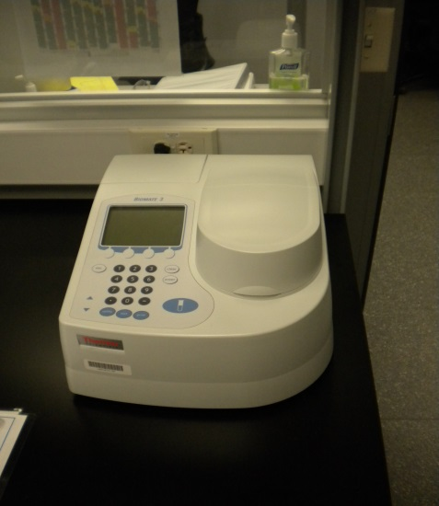

|  |  |
| --- | --- |
| Potential Hazards while performing these activities | |
| Electrical Hazard | This equipment contains liquids during operation. Avoid contact with electrical connections. |
| Chemical Hazard | Chemicals used in this equipment could cause a chemical hazard. Splashes and spills are possible. |
| Fire Hazard | Any improper use of this unit may cause a fire hazard. |

|  |  |
| --- | --- |
| Preventions to reduce exposure to hazards: | |
| Eye Protection | Wear safety glasses with side shields while operating. |
| Protective Gloves | Wear appropriate gloves for chemical usage. |
| Non-slip, closed shoes | Wear non-slip, closed toed shoes to avoid slipping. |
| Read Guide | Become familiar with this guide before operating.  The operating manual is also available for reference. |

|  |  |
| --- | --- |
| Setup/ Operation Steps | Pictures |
| 1. Ensure equipment is on a flat, even surface. Check that the equipment is plugged into an outlet. Turn on Power switch ( 1 = ON, 0 = OFF ) | C:\Users\rmc\Pictures\DSCN1244.JPG |
| 1. Allow machine to run self-diagnostics. | C:\Users\rmc\Pictures\DSCN1237.JPG |
| 1. This step should only be performed if needed. Unit may already be programed. To set up Time/Date, Language, Baseline Expiration and other parameters, press the UTILITY button and follow on screen prompts. Use the arrow key to scroll, use enter to choose option and press escape to exit to the previous screen. |  |
| 1. Select measurement function from Biomate ,tests, stored tests or basic ATC (Absorbance, transmittance, concentration) For anything other than basic ATC refer to manual provided. Basic ATC can be found in the lower right hand corner of the screen. |  |
| 1. To set wavelength, press <set nm> or any number key and scroll to wavelength with the arrow key. Press enter After setting wavelength, press <Change Mode> to set measurement mode to Absorbance, % Transmittance, Concentration with standard or Concentration with factor. |  |
| 1. Before measuring Absorbance (or Concentration), measure a blank. Place blank inside. Close lid. Screen will display“setting blank” while blinking. When blinking stops blank is measured. |  |
|  |  |
| 1. Remove blank after measurement and place cuvette with sample inside. Close lid and measurement will proceed automatically. |  |
| 1. When finished with equipment push the escape button to stop measurement and turn power off. Replace dust cover. | C:\Users\rmc\Pictures\DSCN1245.JPG |