Dynopro Nanostar
Dynopro Nanostar

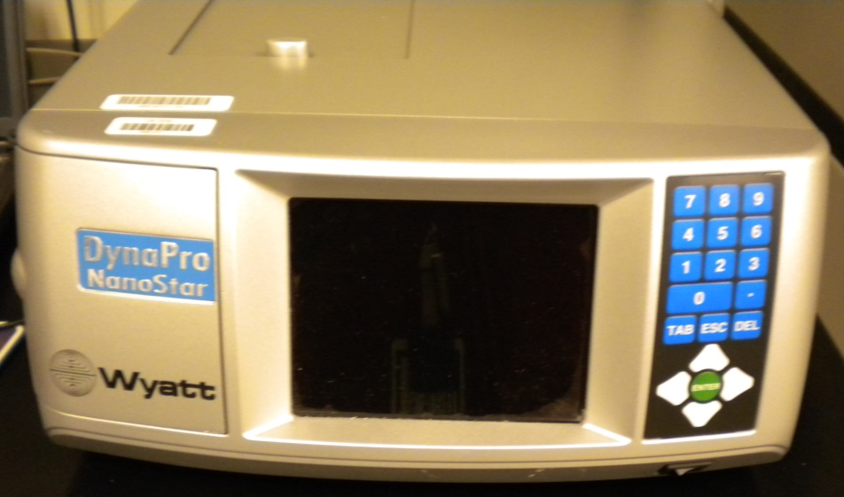
Potential Hazards while performing these activities
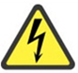 Electrical Hazard | This equipment contains electrical units that may come into contact with skin or liquids.
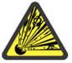 Explosion Hazard | DO NOT USE FLAMMABLE SOLVENTS WITH THIS UNIT.
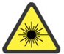 Laser Hazard | This unit generates lasers which may be hazardous without proper protection.
Chemical Hazard | Because chemicals are being used in and near this unit, chemical spills are possible. Be aware of the hazards associated with the chemicals being used and their compatibility with the machine.
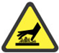 Hot Surface Hazard | The area around the cuvette holder may reach high temperatures, creating a hot surface.

Preventions to reduce exposure to hazards:
Eye Protection | Wear safety glasses while operating.
Protective Gloves | Wear appropriate gloves for heat and chemical usage.
Non-Slip, Closed Shoes | Wear non-slip, closed shoes to avoid spills.
Read Manual | Become familiar with this guide before operating.

Note:
Use either a disposable cuvette or the quartz cuvette. Disposable cuvettes can only be used with the cuvette adaptor. When inserting the adapter of the quartz cuvette there will be 3 edges identical and one different than the rest. The different edge should be on the bottom left when being inserted.

Setup Steps | Pictures
- Ensure that the power plug is plugged into the rear of the unit. | 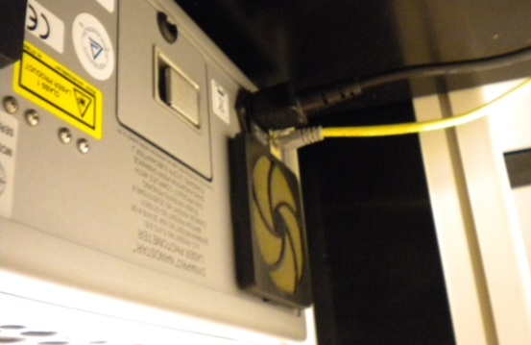
- Without a cuvette installed, turn unit on and allow power and laser to attenuate. | 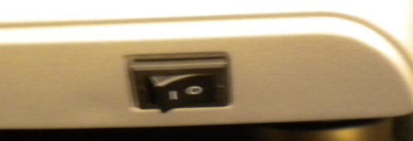
Operation | Pictures
- Open the sample cell door. | 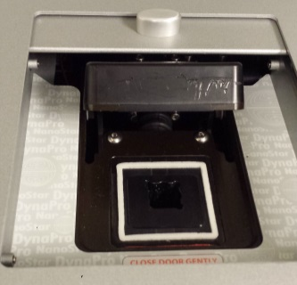
- Place sample in either a disposable cuvette or the quartz cuvette. Use the adapter for disposable cuvettes. | 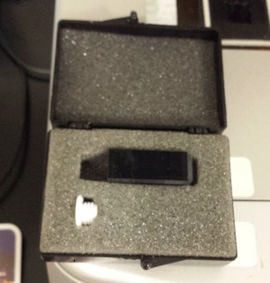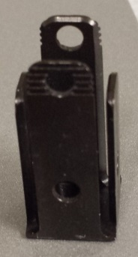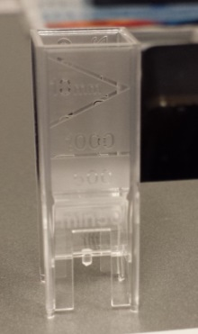
- Put the sample into the machine. If using a disposable cuvette, the adapter must be inserted first. (Refer to the NOTE at the beginning for instructions for inserting the adapter). Make sure that the clear sides of the disposable cuvette are facing front to back. The side with writing should be facing the right and left sides of the machine. | 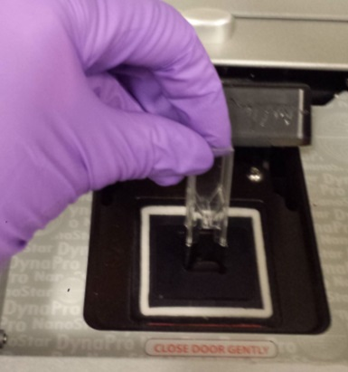
- Click on the DYNAMICS icon. | 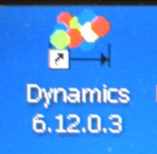
- Press File > New to open a window for a new experiment. | 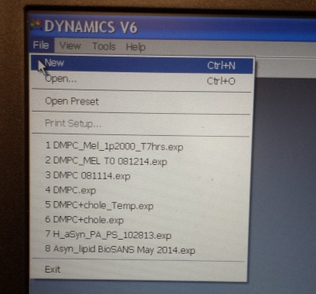
- Click the “connect to hardware” button. The start button will turn green. | 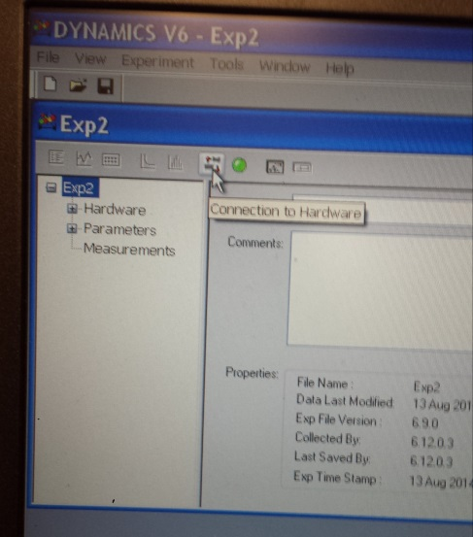
- If desired, designate a title and comments to the experiment. | 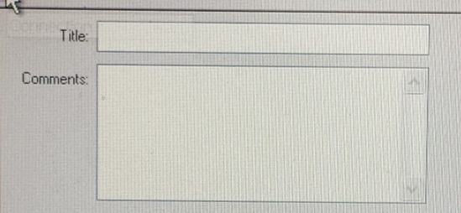
- Click on the Parameters tab to change to the desired parameters for the sample. | 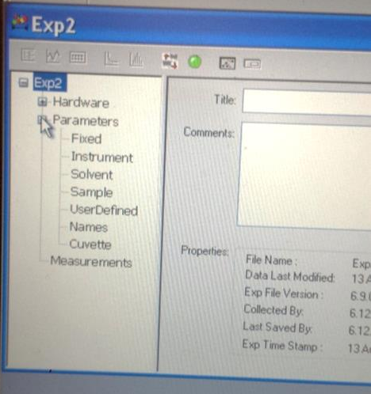
- Click the start button to record data. The button will blink red and gray. Press again if the experiment needs to stop, otherwise, it will stop on its own. | 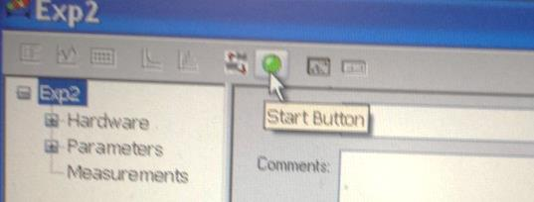
- Click on the Measurements tab to view the measurement result details. If Meas. 1 is selected, it will show a table of all the results. | 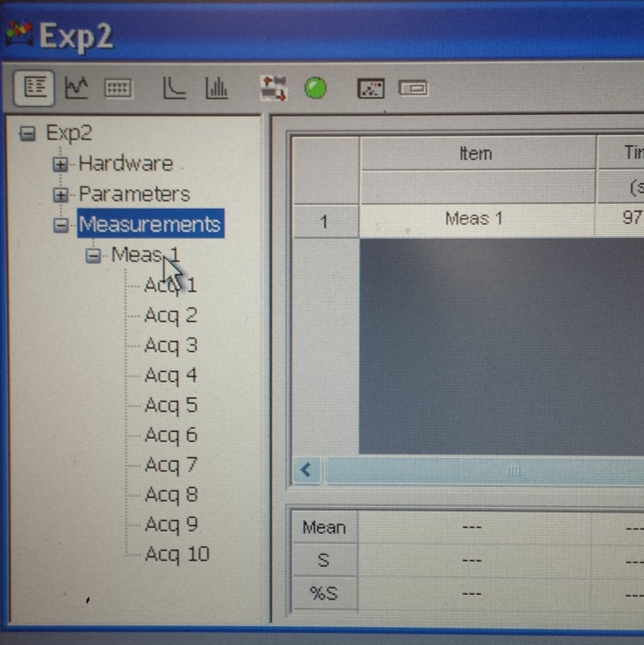
- The buttons across the top are different tools to view the data. | 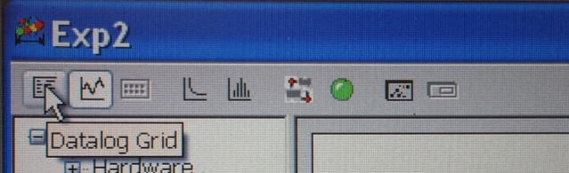
- Select File>Save to save the data.
- Remove the sample. If using the cuvette adapter, return it to where you found it.
- Close DYNAMICS and turn off the nanostar.

