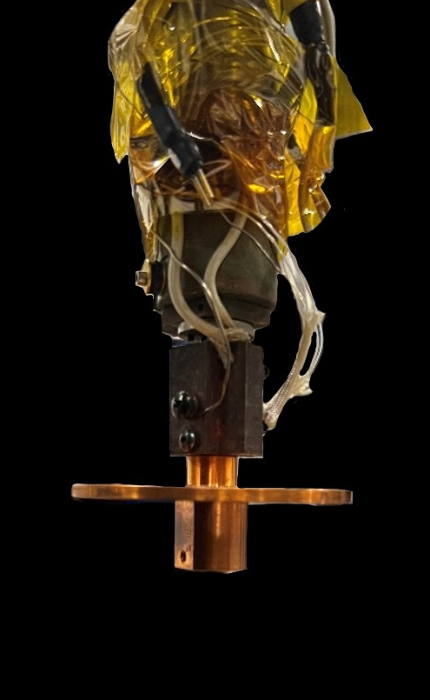
Bottom of flange to beam Center: 1 ⅛”

