Fisher Accuspin Micro 17/17R
Fischer Accuspin Micro 17/17R Microcentrifuge

Microcentrifuge
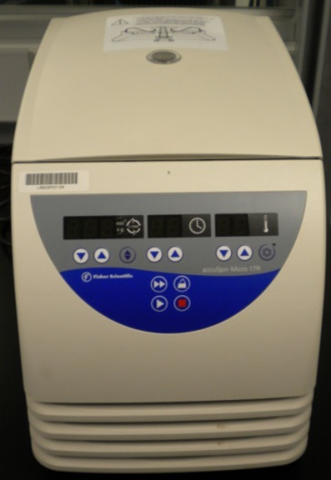
Potential Hazards while performing these activities:
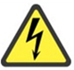 Electrical Hazard | This equipment contains electrical units that may come in contact with skin or liquids.
Slip Hazard | Because liquids are used with this unit, a slip hazard may be created.
Pinch Hazard | This equipment contains moving parts near the lid/agitator that may cause physical harm.
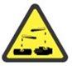 Chemical Hazard | Chemical spills or aerosolization may occur.
Fire Hazard | Any improper use of this equipment may cause a fire hazard.

Preventions to reduce exposure to hazards:
Eye Protection | Wear safety glasses while operating.
Protective Glove | Wear appropriate gloves for heat and chemical usage.
Non-Slip, Closed Shoes | Wear non-slip, closed shoes to avoid spills.
Read Manual | Become familiar with this guide before operating.

Note:
If the rotor is not installed, contact the Lab Space Manager.
Setup Steps | Pictures
- Turn the Main Power switch ON. | 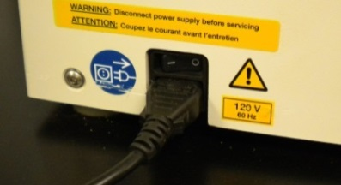
- Allow unit to run initial check. When the speed and time readings show 0, you may proceed. | 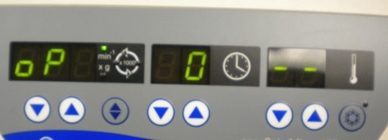
- Press the open lid button and verify the rotor is installed. | 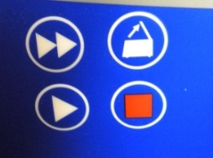
- Load samples into the rotor taking care to balance the load. | 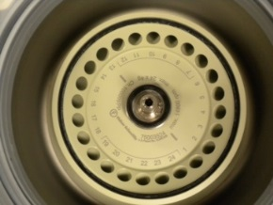
- Gently close the lid.
Operation | Pictures
- Use the RCF/RPM button to select the speed data input. | 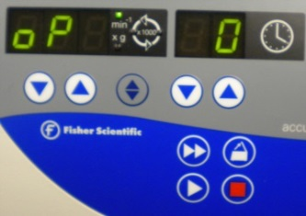
- Press and hold the rotation controls to adjust to desired speed. | 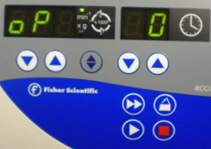
- Use the time controls to set the run time. Holding the down arrow button will set continuous operation.
- Repeat step 3 to set the temperature on 17R models. The LED will flash when the pre-temp is reached. | 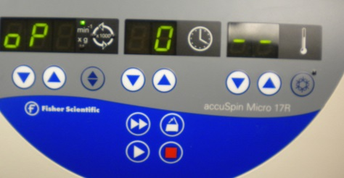
- Press start to begin run. When time expires the instrument will stop. The stop button can be pressed any time to stop the rotor. | 