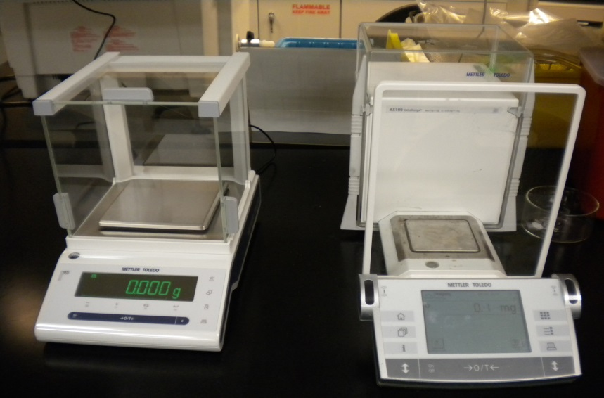

**Mettler- Toledo Balances**

|  |  |
| --- | --- |
| Potential Hazards while performing these activities | |
| ELECTRICAL HAZARD | This equipment contains electrical units that may come into contact with skin or liquids |
| CHEMICAL HAZARD | Because chemicals are being moved to the balance surface, chemical spills are possible. |
| SLIP HAZARD | Because chemicals are being transported to and from unit, a slip hazard may be created. |

|  |  |
| --- | --- |
| Preventions to reduce exposure to hazards: | |
| EYE PROTECTION | Wear safety glasses while operating. |
| PROTECTIVE GLOVES | Wear appropriate gloves for chemical usage. |
| NON-SLIP, CLOSED SHOES | Wear non-slip, closed shoes to avoid spills. |
| READ MANUAL | Become familiar with this guide before operating. |

|  |
| --- |
| **Note**: Some balances have sensors and are motion activated.  **Caution**- Fine powders that are not oxidized could smolder when exposed to air. |

|  |  |
| --- | --- |
| Setup/Operation | Pictures |
| 1. Ensure surface of balance is free of debris and is plugged in. For the most accurate reading ensure your scale is level. Using back feet adjust the balance until the indicator bubble is centered. |  |
| 1. Press the “On/Off” button briefly to switch on balance. The display performs a test for a few seconds and then is ready for weighing. The display should show 0.0mg. |  |
| 1. Press the “0 ” button to set a new zero point. Always use the “0”before you start the weighing procedure. Once a new zero is set the doors will open. |  |
| 1. If you are using a Tare container first zero the balance. Then place your Tare container on the balance and press the “T” button. Doors will close. It will take a few seconds for the balance to measure the Tare container. Upon completion the balance will open and zero with the tare included. |  |
| 1. Place item to be weighed on scale. When you have finished weighing your items turn off the balance. Press and hold the On/Off button until the display message “OFF” appears. |  |