Vacuum Oven – All Models
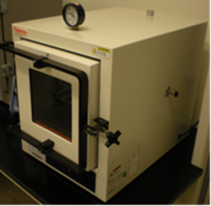
Potential Hazards while performing these activities
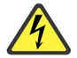 Electrical Hazard | This equipment contains electrical units that may come into contact with skin or liquids.
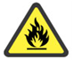 Fire Hazard | Any improper use of this equipment could cause a fire hazard.
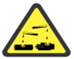 Chemical Hazard | Chemical spills are possible while using this unit.
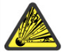 Implosion/ Vacuum Hazard | This unit operates at a negative pressure and can create a vacuum hazard if improperly used.

Preventions to reduce exposure to hazards:
Eye Protection | Wear safety glasses with side shields while operating.
Protective Gloves | Wear appropriate gloves for heat and chemical usage.
Non-slip, closed shoes | Wear non-slip, closed shoes to avoid spills
Read Manual | Become familiar with this guide before operating.

Note:
If you have questions about the operation of this equipment contact the LSM.

Heat Operation | Pictures
- Turn on main power. Check that a thermometer is inside unit to provide internal temperature. | 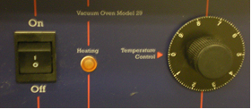
- If the dial is numbered, a key is provided to assist with setting to desired temperature between 40 – 200 degrees Celsius. | 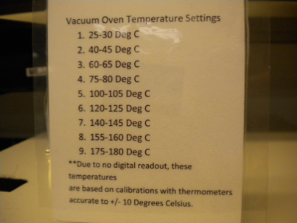
- Allow internal thermometer to reach the desired temperature and monitor for stabilization. | 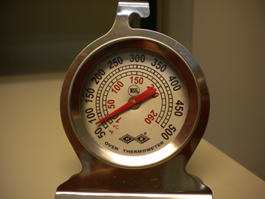
- Place sample inside oven once temperature is stable. If you will use vacuum in addition to heat, please proceed to “vacuum operation” below. If you are only heating, turn off oven and allow oven to cool. | 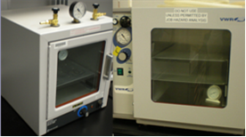
Vacuum Operation | Pictures
- Close valve labeled “VENT” and open valve labeled “VACUUM”. | 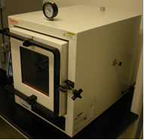
- Latch door and turn on vacuum pump. | 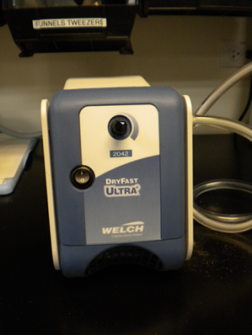
- Monitor vacuum gauge. Vacuum gauge ranges from 0 --30" of Hg (76cm). 0 is equivalent to 1 atm. | 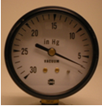
- When required vacuum is reached, CLOSE vacuum inlet valve and turn off vacuum pump. | 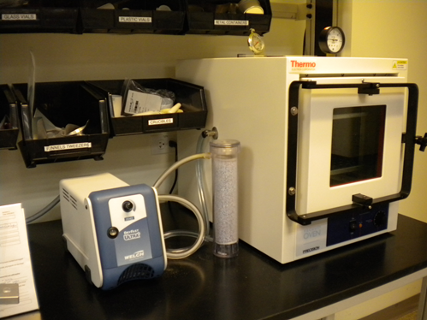
- To return the chamber to atmospheric pressure, open the “VENT” valve very slowly and allow the chamber to re-pressurize. The speed of pressurizing can be controlled by how much the valve is opened. | 