Water Bath All Models
Potential Hazards while performing these activities
Electrical Hazard | This equipment contains liquid near electrical connections.
Heat Hazard | This equipment heats liquids and may cause burns.
Pinch Hazard | This equipment contains moving parts near the lid/agitator that may cause physical harm.
Inhalation Hazard | Because liquids are heated, fumes may be released.
Slip Hazard | Liquids from the water bath may fall on the floor, causing slippery conditions

Preventions to reduce exposure to hazards:
Eye Protection | Wear safety glasses while operating
Protective Gloves | Wear appropriate gloves for heat and chemical usage.
Non-Slip, Closed Shoes | Wear non-slip, closed shoes to avoid spills.
Read Manual | Become familiar with this guide before operating.

Note:
Contact LSM for additional questions about operating this equipment.

Setup Steps | Pictures
- Check the operating level of the water. Ensure drain is closed before adding water. Add water if needed. Ensure that bath is plugged into the electrical outlet. | 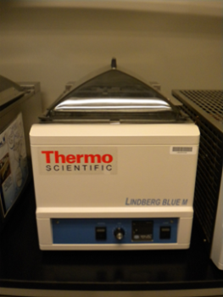
- If using chiller (if available), check that unit is plugged in and connected. | 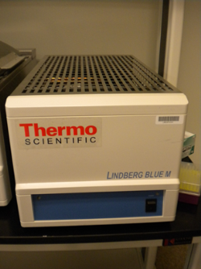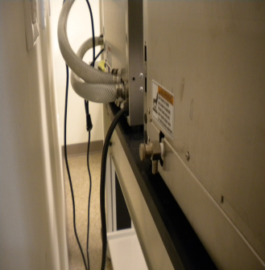
- Add sample to bath using floating rack or appropriate glassware. Make sure samples are properly sealed to prevent spilling into the water bath. | 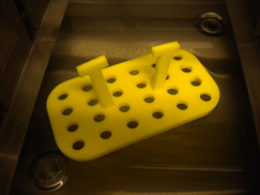
- Ensure lid is seated correctly to allow agitation bars to move back and forth. | 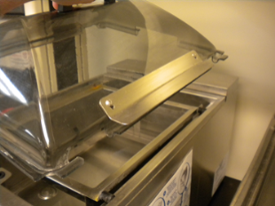
Operation | Pictures
- Turn unit power on and turn on agitation if desired. | 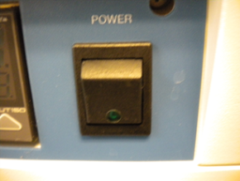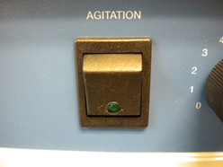
- Adjust agitator dial to desired cycles per minute. | 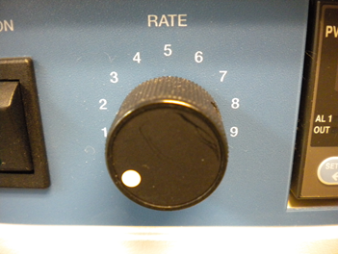
- If temperature requires the optional chiller, turn chiller power on for temperatures below 30C (86F). If operation below 10c is required, a special solution must be used to prevent ice buildup in the circulation system. Contact the lab space manager. | 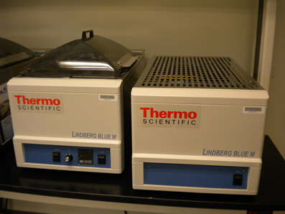
- To set temperature, press the arrow buttons until the desired temperature set point is reached. Allow adequate time for temperature to be achieved. | 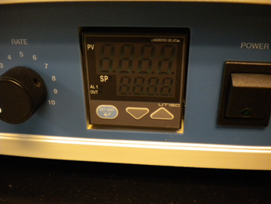
- When finished, turn off unit and chiller. Remove samples and replace lid. | 