POWGEN User Manual for Data Reduction:

The analysis machines are called powgen (powgen.sns.gov) and powgen2 (powgen2.sns.gov). The reduction of data from powgen is done using mantidplot.

To start the program type “mantidplot” in a terminal window on either of the two analysis computers (these are on the right side of the hutch). If this is your first time, pull down the menu at red hat, go to system and make a shortcut for a terminal on the desktop or launcher panel. Standard data is automatically reduced using mantidplot and stored in the following folder

/data/SNS/PG3/IPTS-xxxx/shared/autoreduce

Four files are stored for each run number. The extension .gsa is used for gsas data file, .dat is used for fullprof data file, .xye for topas data file and a python file is stored that show which algorithms in mantidplot were applied to the raw data to produce these data files. It also creates a summary file called PG3_IPTS-xxxx_runsummary.csv that gives an summarized table of all the run information.

nxsummarytable: This is a very useful command which can be entered at the command prompt to find a summary of run files with some logs to keep track of the experiment. The run sequence should be entered the same way as is stated for the Mantid script. Like any other Unix command the output can be directed to a text file and this will produce a csv (comma separated) file of the summary, e.g.

nxsummarytable 1370-1400, 1450-1455 > summaryIPTS1582-PG3.txt

will create a file in the current directory with the summary information of runs 1370 to 1400 and 1450 to 1455. On the analysis cluster computer –i option will be needed as explained later.
Accessing Data:

- You will need an XCAMS account to access data collected at the instrument. If you entered the proposal you already have an account. Make sure any team member who needs to access data also has an XCAMS account. https://xcams.ornl.gov/xcams/regStep1.shtml
- Next you will have to request the resources for the beamline. Pick SNS user (on and off site) and POWGEN. https://neutronsr.us/accounts/request.html
- The two steps before will get you access to our portal and analysis computer. However, if you want to look at the data on your personal computer, the easiest way to make it happen is installing nxclient. Instructions for setting up nxclient follows:
Run NX machine wizard with the following link: http://analysis.sns.gov/
click the LAUNCH button that appears in the applet. This will fire up an NX session to a cluster node. If you disconnect your NX session you will end up on the same node the next time you connect. Note special instructions are provided for those who use Lion.
- Once you login under your home directory you will see the following folder structure /data/SNS/PG3/IPTS-XXXX/. All the run numbers will appear for your data. Data is automatically reduced to gsas and fullprof files using the default parameters. Those data can be found in the /shared/autoreduce folder. You can of course re reduce data with other binning values using mantidplot.
- Secure ftp or secure shell will allow you to get the data onto your local drive. One such program can be downloaded from http://filezilla-project.org/download.php?type=client
Enter the following information to connect to the analysis computers:
Host: analysis.sns.gov
Username and password
Port: 22
- Parameter files for GSAS and IRF files for fullprof can be downloaded from the instrument website http://neutrons.ornl.gov/powgen/users.shtml. Be sure to pick the correct cycle. Also these files are stored in the /SNS/PG3/run_cycle_11A_CAL folder in the analysis computer where cycle is year_1 or year_2 based on cycle A or B.
- To get a summary of runs, first you have to download a file called .nxsummary.conf in your home directory from the web or copy it from (/SNS/PG3/2012_2_11_CAL). This is a hidden file so you will have to change your view to see the file. This will give you all the relevant information for your summary. Then open a terminal window in the analysis computer and type
nxsummarytable –i PG3 run#-run# > table.txt

This will create a csv file with the summary called table.txt.

Other Useful commands:

Mantid creates workspaces. If you right click on this workspace you can do various different types of plot. Once the data is reduced you can also see all the logs e.g. temperature, chopper, etc. and plot them by double clicking the field. Useful commands are (In the Algorithms panel type in the following commands and hit return or click Execute)
- LoadGSS (to load a GSAS file): This data will be plotted as a function of tof.
- convertunits (to change x axis e.g. to d-spacing).
- LoadMultipleGSS: Here a series of runs can be specified and the workspace will be loaded with d spacing as x-axis.
- conjoinfiles (to make 2D plot, however data from same wavelength has to be used for this)

Many other algorithms are available and learn more go to

Mantid website http://www.mantidproject.org/Main_Page.

SNSPowderReduction:
If you want to rebin the data (different from what autoreduce creates) or do some special subtraction of background, you can reduce the data using Mantid. In the Algorithms panel type in “SNSPowderReduction” and hit return or click Execute. This will launch the script (see screenshot above). Once the fields are all specified, hit Run to reduce data. Fields to enter in this script are as follows
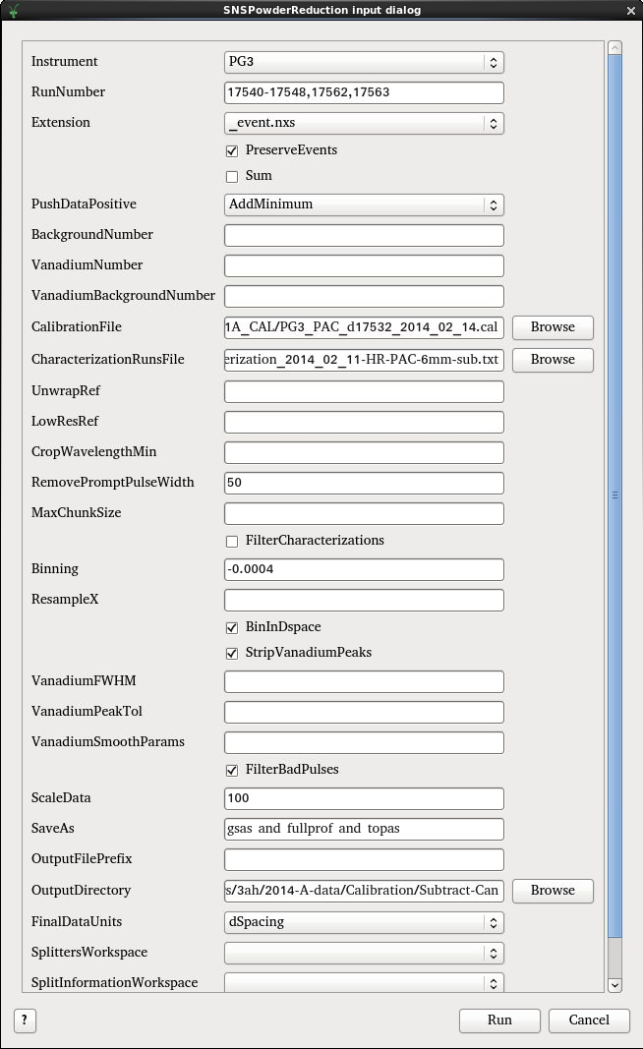
- Instrument : PG3
- RunNumber: This can be a single number or a range of numbers separated by comma. Multiple ranges can also be entered via comma separation. For example “2300-2350, 2355, 2360-2365” is a valid entry. When the Sum box is checked, the ‘-‘ means range of data to be summed together.
- PushDataPositive: There are three available options, None, ResetToZero and AddMinimum. If due to subtraction the counts go –ve it will add a constant value to the spectrum so that all counts are +ve (AddMinimum) or reset those –ve numbers to Zero (ResetToZero) or do nothing(None).
- BackgroundNumber and VanadiumNumber should be added only if you chose to not use the default run numbers set in the CharacterizationRunsFile. In this case time min and time max has to be included in the binning field, along with the bin width. If you enter -1, that will ignore that file. This is a good way to generate the raw file without normalization and background subtraction.
- CalibrationFile: This data is stored in the folder:
SNS/PG3/’run_cycle_11A_CAL’ and has an extension .cal for example the calibration file for run cycle 2011_B is SNS/PG3/2011_2_11A_CAL/PG3_FERNS_d4832_2011_08_12.cal
- CharacterizationRunsFile: This is a simple text file that lists all the instrument standard Vanadium and Background data collected for various different center wavelengths at Powgen. The default file lists appropriate V and Empty run #s for PAC. For other sample environments if users want to do background subtraction a new characterization file should be created or the BackgroundNumber should be specified in the main GUI. There may be multiple characterization files for various settings so users should pay special attention to the one they use.
- LowResRef: This should be left empty starting cycle 2013B
- RemovePromptPulseWidth = 50
- FilterbyTimeMin & FilterbyTimeMax: This allows users to chop the data (making use of event mode data) by specifying the start time and end time (in seconds).
- Binning: This is the bin width. For linear binning, enter binwidth in microseconds for time or angstrom for d. For logarithmic binning enter a –ve sign before the value of δt/t. “-0.0006” is a good starting point and works for most datasets. However, the users can choose this value based on what is needed for their individual samples.
- The next two fields are associated with cutting out the V peaks from the V spectrum and a smoothing operation and should be left empty (default).
- FilterBadPulse should be checked. This takes out any background collected during accelerator faults and down periods.
- FilterByLogValue: This is a variable of the log to be filtered e.g. chopper, temperature etc. Since we have an event based data collection mode it is possible to define strict filter values for soft controls such as sample environment after the data is collected.
- FilterMinimumValue and FilterMaximumValue: Min and max value for the filter variable.
- ScaleData: Some Rietveld programs have problems with plotting tick markers if the data is too close to the zero base line. By default (autoreduction) we use a push positive data and multiply by 100.
- Saveas: Available file formats are
  - gsas
  - fullprof
  - topas
  - pdfgetn
  - processed nexus
to generate multiple format just use ‘and’.
- OutputFilePrefix: If the Sum box is check to sum multiple dataset, this allows the user to specify the file name for the summed dataset.
- OutputDirectory: Directory in which the reduced file should be saved. Users can use the Browse to select desired location.

