POWGEN User Manual for Data Reduction:

The analysis machines are called powgen (powgen.sns.gov) and powgen2 (powgen2.sns.gov). These two machines are available to users on site. If you are trying to access data outside ORNL you will need to access it via our analysis cluster. Following is a detailed description of how to access data.

Accessing Data:

- You will need an XCAMS account to access data collected at the instrument. If you entered the proposal or did a training while at ORNL you already have an account. Make sure any team member who needs to access data also has an XCAMS account. https://xcams.ornl.gov/xcams/regStep1.shtml
- If you have forgotten your password, go to https://user.ornl.gov/Account/Login
And you will be able to retrieve your password by using the “Forgot your password?” link.
- The steps before will get you access to our portal and analysis computer. However, if you want to look at the data on your personal computer, the easiest way to make it happen is installing nxclient. Instructions for setting up nxclient can be found in http://analysis.sns.gov/
Users of Mac and Linux should refer to special instructions.
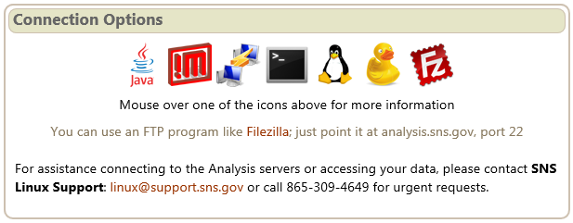

- Once you login, under your home directory you will see the following folder structure /data/SNS/PG3/IPTS-XXXX/. All the run numbers will appear under the subfolder 0. If you don’t see these folders in your home directory try looking in /SNS/PG3/IPTS-xxxx. Data is automatically reduced to gsas, fullprof and topas files using the default parameters. Those data can be found in the /data/SNS/PG3/IPTS-xxxx/shared/autoreduce folder. You can of course re reduce data with other binning values using mantidplot.
  - The extensions are
    - .gsa for GSAS
    - .dat for fullprof
    - .xye for topas
- Secure ftp or secure shell will allow you to get the data onto your local drive. One such program can be downloaded from http://filezilla-project.org/download.php?type=client
Enter the following information to connect to the analysis computers:
Host: analysis.sns.gov
Username and password
Port: 22
- A summary of runs is automatically generated along with data reduction and is called PG3_IPTS-XXXX_runsummary.csv which is a csv file with all relevant information about the runs.

- Parameter files for GSAS and IRF files for fullprof can be downloaded from the instrument website http://neutrons.ornl.gov/powgen/users.shtml. Be sure to pick the correct cycle. Also these files are stored in the /SNS/PG3/IPTS-2767/shared/run_cycle_11A_CAL folder in the analysis computer where cycle is year_1 or year_2 based on cycle A or B. This location is starting 2014B. Earlier cycles, the cal folders are stored in /SNS/PG3.

The parameter and IRF file names have HR or HI to denote High Resolution or High Intensity mode used for data collection. If the guide value is -56.863 in your summary file then the data was collected using HR while if the value is 162.645 then the data was collected using HI guide.

Data Reduction:

All data is reduced using a program called mantidplot. Type “mantidplot” in a terminal window on either the analysis cluster or on the local machines to start the program. If this is your first time, pull down the menu at red hat, go to system and make a shortcut for a terminal on the desktop or launcher panel.

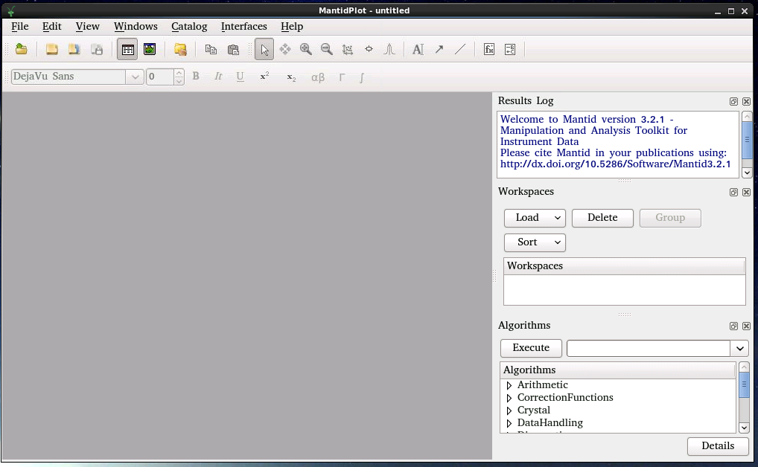
If you want to rebin the data (different from what autoreduce creates) or do some special subtraction of background, you can reduce the data using Mantid. In the Algorithms panel type in “SNSPowderReduction” and hit return or click Execute. This will launch the script (see screenshot above). Once the fields are all specified, hit Run to reduce data. Fields to enter in this script are as follows.

SNSPowderReduction:

- Instrument : PG3
- RunNumber: This can be a single number or a range of numbers separated by comma. Multiple ranges can also be entered via comma separation. For example “2300-2350, 2355, 2360-2365” is a valid entry. When the Sum box is checked, the ‘-‘ means range of data to be summed together.
- PushDataPositive: There are three available options, None, ResetToZero and AddMinimum. If due to subtraction the counts go –ve it will add a constant value to the spectrum so that all counts are +ve (AddMinimum) or reset those –ve numbers to Zero (ResetToZero) or do nothing(None).
- BackgroundNumber and VanadiumNumber should be added only if you chose to not use the default run numbers set in the CharacterizationRunsFile. In this case time min and time max has to be included in the binning field, along with the bin width. If you enter -1, that will ignore that file. This is a good way to generate the raw file without normalization and background subtraction.
- CalibrationFile: This data is stored in the folder:
SNS/PG3/’run_cycle_11A_CAL’ and has an extension .cal for example the calibration file for run cycle 2011_B is SNS/PG3/2011_2_11A_CAL/PG3_FERNS_d4832_2011_08_12.cal
- CharacterizationRunsFile: This is a simple text file that lists all the instrument standard Vanadium and Background data collected for various different center wavelengths at Powgen. The default file lists appropriate V and Empty run #s for PAC. For other sample environments if users want to do background subtraction a new characterization file should be created or the BackgroundNumber should be specified in the main GUI. There may be multiple characterization files for various settings so users should pay special attention to the one they use.
- LowResRef: This should be left empty starting cycle 2013B
- RemovePromptPulseWidth = 50
- Binning: This is the bin width. For linear binning, enter binwidth in microseconds for time or angstrom for d. For logarithmic binning enter a –ve sign before the value of δt/t. “-0.0006” is a good starting point and works for most datasets. However, the users can choose this value based on what is needed for their individual samples.
- The next two fields are associated with cutting out the V peaks from the V spectrum and a smoothing operation and should be left empty (default).

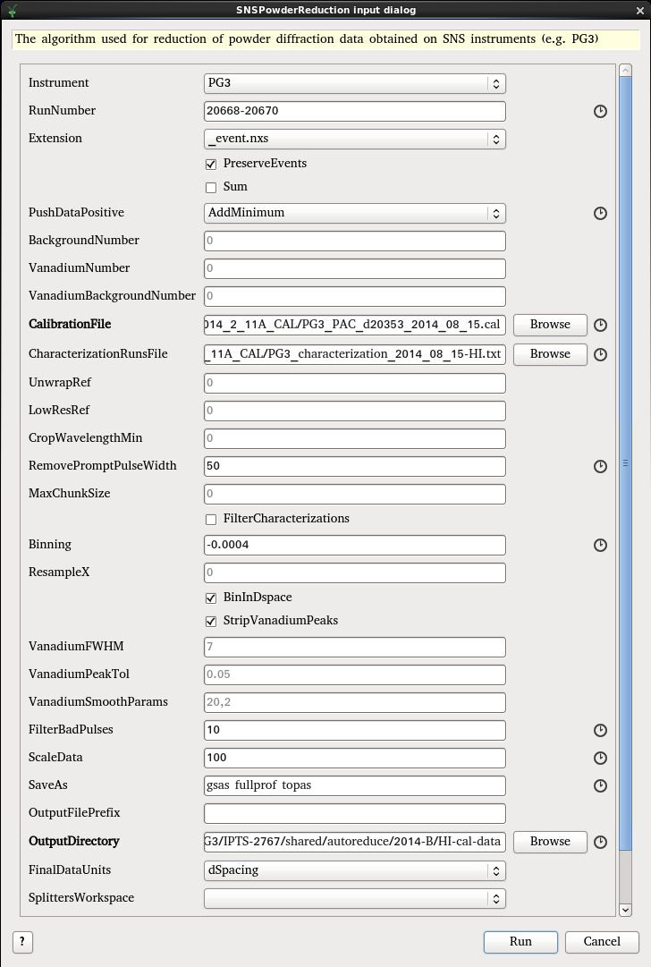
- FilterBadPulse = 10. This takes out any background collected during accelerator faults and down periods.
- ScaleData: Some Rietveld programs have problems with plotting tick markers if the data is too close to the zero base line. By default (autoreduction) we use a push positive data and multiply by 100.
- Saveas: Available file formats are
  - gsas
  - fullprof
  - topas
  - pdfgetn
  - processed nexus
to generate multiple format just use ‘and’.
- OutputFilePrefix: If the Sum box is check to sum multiple dataset, this allows the user to specify the file name for the summed dataset.
- OutputDirectory: Directory in which the reduced file should be saved. Users can use the Browse to select desired location.

Slicing data by slow control log values or Time:

In the main menu pick DiffractionPowder Diffraction Reduction

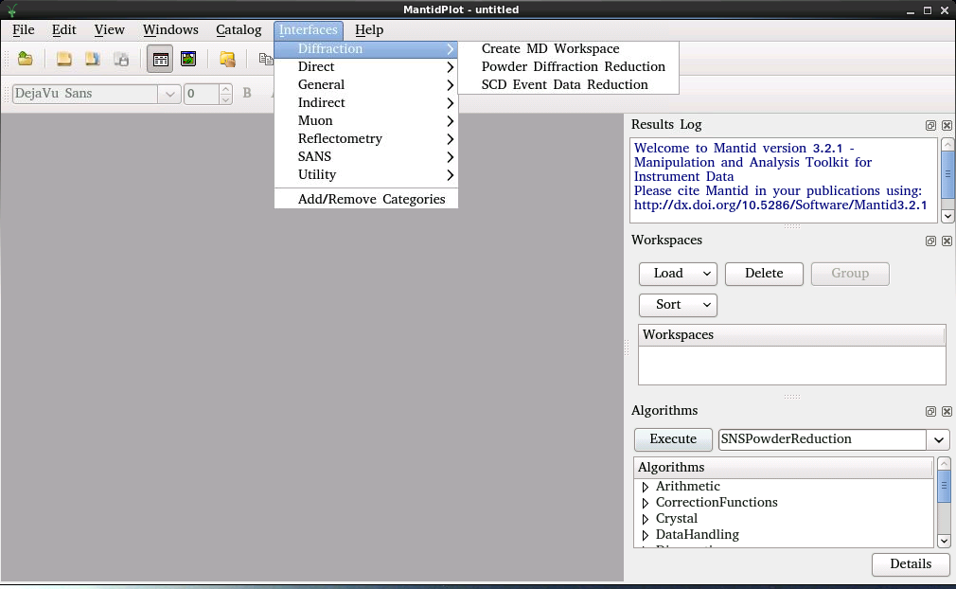

This will launch the following window. Most of the inputs are identical to the ones used in SNSPowderReduction.

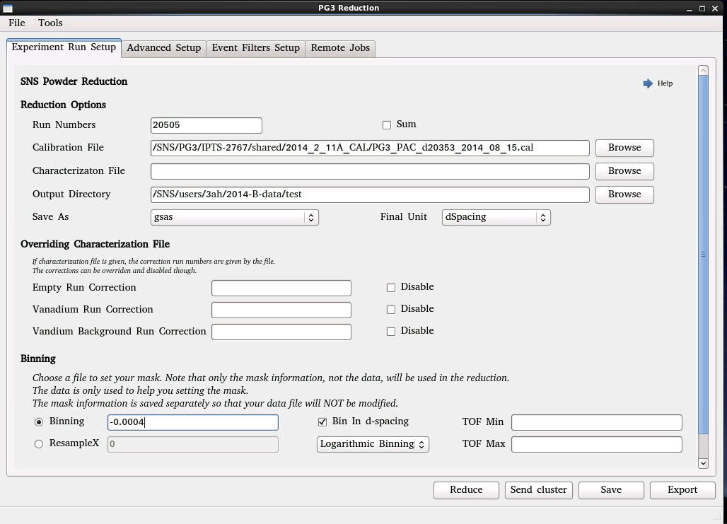

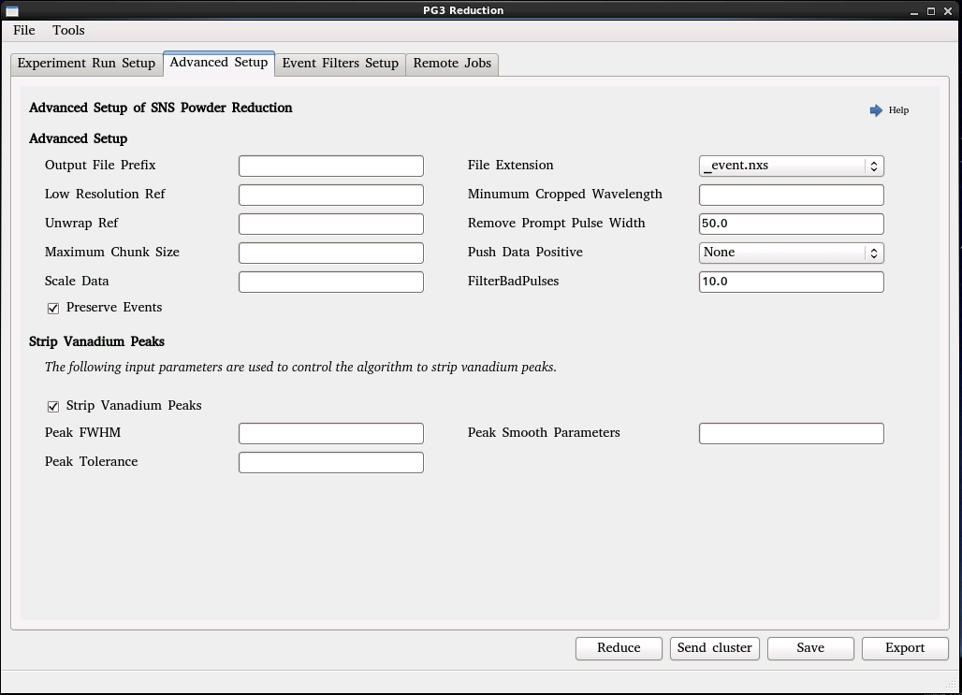

You will need to use the tab titled Event Filters Setup to setup the required slicing. You have various options to slice by time or by log value.

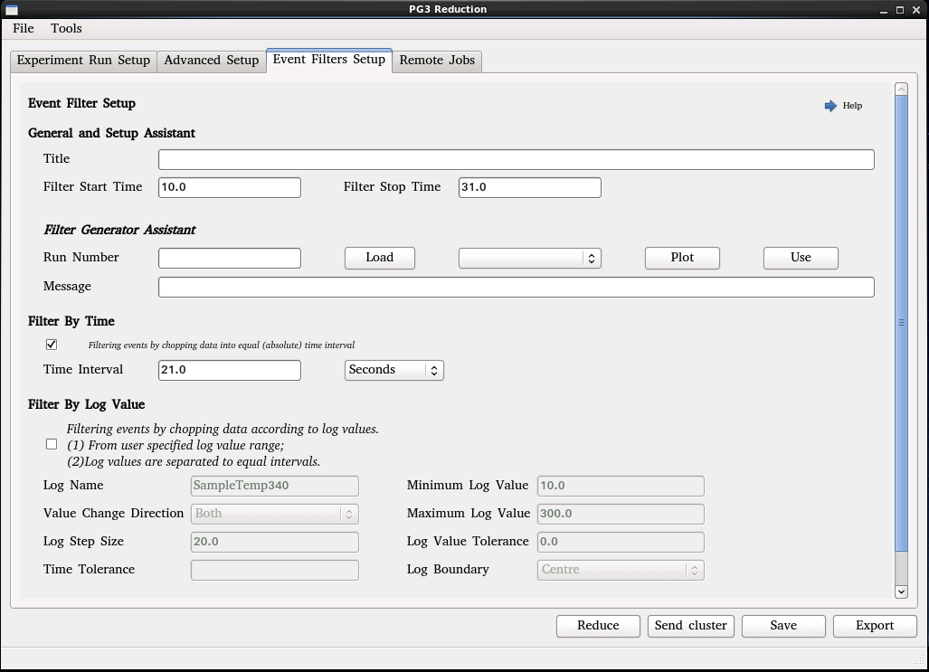

Other Useful commands:

Mantid creates workspaces. If you right click on this workspace you can do various different types of plot. Once the data is reduced you can also see all the logs e.g. temperature, chopper, etc. and plot them by double clicking the field. If the data is already reduced and you are interested in looking at any log value, use the command LoadEventNexus to load the Nexus file. Make sure to check Load Logs.

Useful commands are (In the Algorithms panel type in the following commands and hit return or click Execute)
- LoadGSS (to load a GSAS file): This data will be plotted as a function of tof.
- convertunits (to change x axis e.g. to d-spacing).
- LoadMultipleGSS: Here a series of runs can be specified and the workspace will be loaded with d spacing as x-axis.
- conjoinfiles (to make 2D plot, however data from same wavelength has to be used for this)

Many other algorithms are available and learn more go to

Mantid website http://www.mantidproject.org/Main_Page.

